Year 11 Transition to A level Music

Welcome to the Music at Beths Grammar School. I look forward to seeing all you year 11s in September. Usually we set a few tasks at induction day for the summer break, but given that you have a bit more time and it is uncertain what will happen in the summer term, we have put together some tasks for you to complete before you start your A level music course. There are some history, listening, composition and research tasks for you to have ago at*.
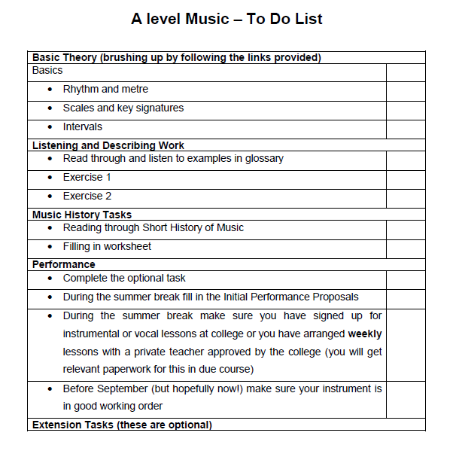

Summary of the Eduqas A Level Course
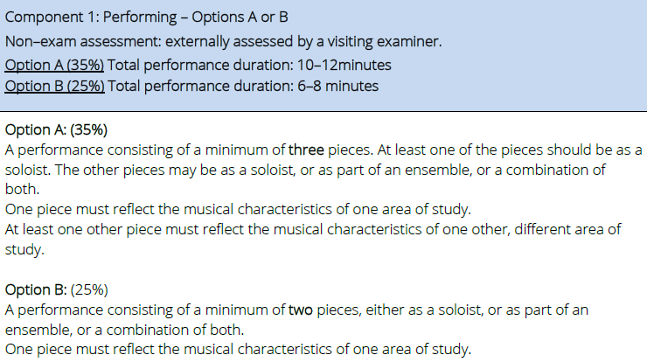
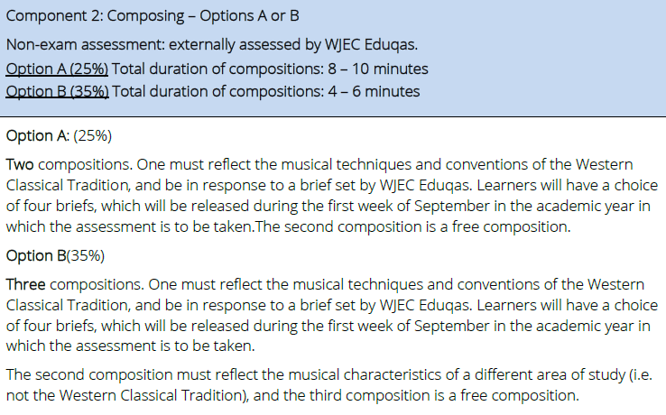
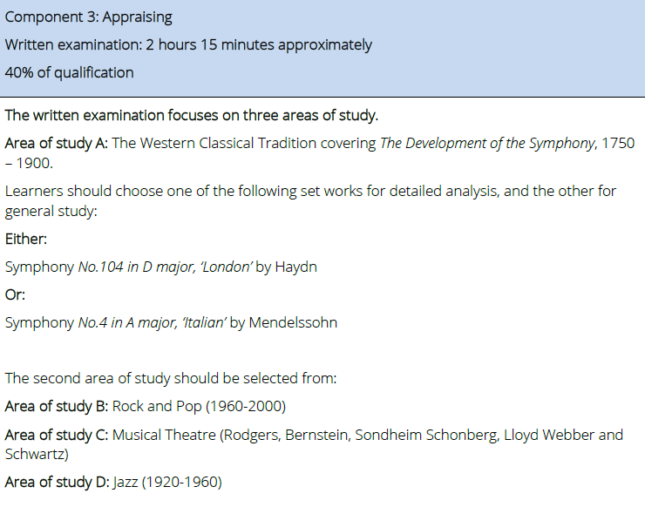
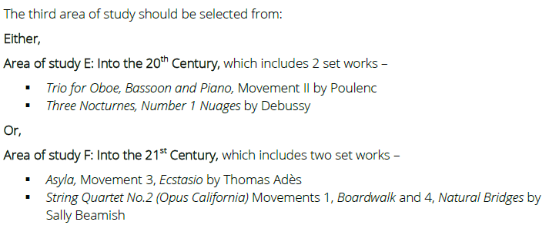

For example, this year we chose to study the following areas of study:
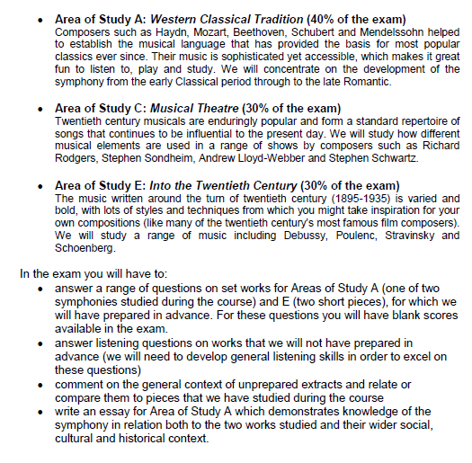
Basic Theory
When we start the A level course, we begin by reviewing basic theory through some simple tasks. We will go over keys, triads, dissonance etc. but I do presume some basic knowledge. On the following webpage page, you should be familiar with the topics in the following sections:
Musictheory.net
- The Basics – all sections
- Rhythm and Metre – all sections
- Scales and Key Signatures – all sections
- Intervals – all sections
- The first two lessons from Chords, Diatonic Chords and the first from Chord Progressions would be a bonus
Music History
Read through and listen to the material on the Short History of Music pages located on this hyperlink and then complete the worksheet below. You can either print it off and complete by hand or fill it in as a word documents and then print them off:
Short History of Music Worksheet (Word)

Listening and describing
As in GCSE Music, we will need to get really good at describing music using appropriate technical terms.
I would like you to review all the terms in the GCSE Glossary, which should be familiar from many GCSE courses. Make sure you understand them, follow all the links and listen to the examples before completing the two listening exercises.
Exercise 1 – Western Classical
Listen to this Beethoven String Quartet extract and answer the questions in the worksheet. You will need to print out the worksheet and then listen play the video so you can see to which parts of the music the questions refer. You can watch the video as many times as you wish and pause it where you need to do so. You should also refer back to the the terminology from the GCSE Glossary to make sure you are talking about the right things and using correct language.
Exercise 1 Worksheet
Exercise 2 – Musical Theatre
Exercise 2 Worksheet
Listen to the attached Extract ‘Last Midnight’ from Stephen Sondheim’s Into the Woods and answer the questions in the worksheet. Print out the worksheet single sided. You can listen as many times as you like. Some of the short questions are easy and some are pretty hard. Just do your best!

Performance
Make sure you don’t neglect your playing during this break. If you are having online lessons with your teacher, then that will obviously keep you going. If you are not, I suggest you do at least some of the tasks below to keep yourself in practice.
- Polish up a piece you are already working on and video it. You could then share it with your friends and family. In due course, I will ask you to email me a video of you playing a short extract. If you want to get ahead of the game send it to me at msmarriott@beths.bexley.sch.uk. You might find a recorded accompaniment on YouTube for pieces that are very regularly played for grades etc.
- Resurrect an older piece that you really enjoyed. You will be able to play it better now you are a bit more advanced. Listen to some performances of the piece on Apple Music/Spotify/YouTube. What do you like about these performances? Is there anything you can incorporate? Again, you could video your performance.
- Look at the graded lists for the level at which you are currently playing. Listen to the pieces and choose one to learn from scratch. You can use recorded performances to help you learn the piece and decide how to play it.
Extension Tasks
If you are looking for other things to keep you busy, pick a selection from the following tasks.
Reading
- Sion, Colborne, Gardiner, Pankhurst et al (2017) Eduqas AS and A Level Music Study Guide, London: Rhinegold (Amazon link) [covers the background information needed for the course – useful but not essential to read before the A level starts]
- Winterson and Harris (2014) Music Theory: The Essential Guide London: Faber (Amazon link) [ if your basic theory is a bit ropy then this is good for making sure you know up to Grade 5 theory stuff]
- Read the following interview with Stephen Sondheim.
- Landon (1966) Haydn Symphonies: BBC Music Guides
- Clark (2001) The Cambridge Companion to Haydn: Cambridge University Press
- Horton (2013) The Cambridge Companion to the Symphony: Cambridge (Amazon)
- Steinberg (1998) The Symphony: A Listener’s Guide: OUP (USA) – this is also available as e-download (ISBM: 978 01951 26655)
- Steen (2004) Mendelssohn: The Great Composers: Icon Books Ltd
Stuff to watch on Youtube
- Some really simple explanations of basic music theory building blocks at 12tone, Starts with some ludicrously basic stuff but moves on to go over basics that you might be rusty on.
- Good basic introduction to the symphony by Howard Goodall from the BBC
- A much longer video on the symphony by Howard Goodall (this is the first of a series)
- An introduction to Debussy, again from Howard Goodall at the BBC
- Anything on the LSO Youtube Playlist
- During the COVID 19 lockdown you can access archived Berlin Philharmonic concerts – amazing!
- Lloyd Webber is streaming his musicals free on Friday nights on theshowsmustgoon
- And here is a massive list of performing arts stuff you can access from home during lockdown. Most of if free or very cheap.
- Watch/listen to Take Me to the World: A Sondheim 90th Birthday Celebration
- Composition task from Passing Notes free during lockdown by using the code COVID19
- Watch the following short video of the composer discussing her work Composing Myself: Judith Weir
Composition 1
Can you write an eight-bar melody in the Classical style that is like the extract below. Either write it for string quartet in Noteflight, Musescore or on paper or write it for a melody instrument with piano chords. Notice that the harmony is quite simple, the melody sticks closely to the chords with just simple decorations, bar 3-4 and 7-8 are cadences. You can look at the notes here if you want some technical tips:
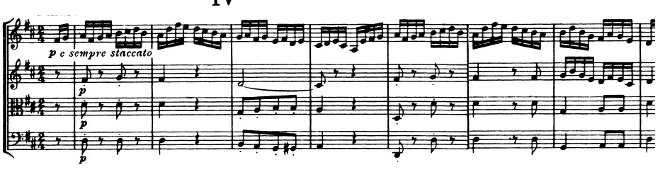Audio for the above notation (this is the whole movement)

Composition 2
Can you write a pentatonic piece, taking the extract below as inspiration? You can read the notes here to help you if you wish. Write for any combination of instruments.
Listening Tasks
- Work on your listening skills by completing some aural exercise. Here are some suggested websites to help you Teoria, Dolmetsch, Auralia, Philharmonia, Music Maestro and Music Trainer.
- Listen to music as much as possible whilst trying to identify musical features, below is a recommended playlist. Note that this includes works from all areas of study, although the development of the symphony is compulsory, so it would be worth looking at these in more depth.
Development of the Symphony:
- Johann Stamitz No. 2 Op.3 in D
- Haydn, No. 26 in D minor
- Haydn, No 104 in D ‘London’
- Mozart, No. 38 in D ’Prague’
- Beethoven, No 3 in Eb ‘Eroica’
- Beethoven, No. 6 in F ‘Pastoral’
- Beethoven, No 9 in D minor ‘Choral’
- Berlioz, Symphonie Fantastique
- Schubert, No. 8 in B minor ‘Unfinished’
- Schumann, No. 4 in D minor
- Brahms, No. 2 in D
- Liszt, Faust Symphony
- Anton Bruckner, No 7 in E
- Dvorak, No 8 in G minor
- Tchaikovsky, No 5 in E minor
- Mahler, No1 in D minor ‘Titan’
- Mendelssohn, No 4 in A ‘Italian’
- Mozart, No 40 in G minor
- Haydn, No 45 in F# minor ‘Farwell’
- Schubert, No 9 in C ‘The Great’
- Brahms, No. 3 in F
- Tchaikovsky, No6 in B minor ‘Pathetique’
- Beethoven, No. 5 in C minor
- Mahler, No. 2 in C minor – E Flat
- Schumann, No.1 in Bb ‘Spring’
- Bach, Op.18 No. 4 in D
- Mozart, No1 in Eb
- Bruckner, No.9 in D minor
- Mendelssohn, No.3 in A minor ‘Scottish’
- Dvorak, No.9 in E minor ‘New World’

Rock and Pop 1960-2000
- Students should listen to music from the following genres/artists/groups:
  - Pop
  - Rock (including progressive rock, heavy metal, folk-rock and punk rock)
  - Soul
  - Funk (and disco)
  - Folk (and country)
- 60’s- Beatles, Shadows, Kinks, Who, Led Zeppelin, Rolling Stones, Eric Clapton, Jimi Hendrix, Joan Baez, Joni Mitchell, Bob Dylan, Sam Cooke, Otis Reading, Aretha Franklin, Four Tops
- 70’s- Abba, Bee Gees, Queen, Beach Boys, Deep Purple, Alice Cooper, Black Sabbath, James Brown, Stevie Wonder, The Temptations, Marin Gaye, Kool and the Gang, Diana Ross, Chaka Khan Pink Floyd, ELO, Kate Bush, Billy Joel, Elton John
- 80’s – Culture Club, Police, Spandau Ballet, Duran Duran, Guns n Roses, AC/DC, Bon Jovi, Journey, Luther Vandross, Prince, Michael Jackson, Shalamar, Earth Wind and Fire
- 90’s Take That, Oasis, Blur, Stereophonics, Nirvana, Red Hot Chili Peppers, Metallica, Pearl Jam, Mary J Blige, Whitney Houston, Bobby Brown, R. Kelly

Musical Theatre
- Students should listen to works from the following composers:
  - Richard Rodgers: Pal Joey, Babes in arms, The Boys from Syracuse, Oklahoma, Carousel, South Pacific, The King and I, The Sound of Music, Flower Drum Song, Cinderella, Do I hear a Waltz.
  - Leonard Bernstein: West Side Story, On the Town, Wonderful Town, Candide
  - Stephen Sondheim: A funny thing happened on the way to the forum, Anyone can whistle, Company, Follies, A little night music, Sweeney Todd, Pacific Overtures, Merrily we roll along, Sunday in the park with George, Into the woods, Assassins, Passion, Bounce/Road show
  - Claude-Michel Schönberg: Les Miserables, Miss Saigon, Martin Guerre, The Pirate Queen, Marguerite
  - Andrew Lloyd Webber: Joseph and the Amazing Technicolour Dreamcoat, Jesus Christ Superstar, Evita, Cats, Starlight Express, Phantom of the Opera, Aspects of love, Sunset Boulevard
  - Stephen Schwartz: Godspell, Pippin, The Magic Show, The Baker’s Wife, Wicked, Children of Eden

Jazz 1920-1960
- Students should listen to music from the following genres of Jazz:
  - Ragtime
  - Dixieland
  - Early jazz
  - Big band (including swing)
  - Be-bop
  - Cool jazz
- For example, use these are a reference:
- Scott Joplin: The Entertainer, Maple Leaf Rag, Pine Apple Rag, Heliptrope Bouquet
- Jelly Roll Morton: Black Bottom Stop (Red Hot Peppers), Wolverine Blues, Kind Porter Stomp, Grandpa’s Spells, Dr Jazz
- Louis Armstrong: Twelfth Street Rag, Potato Head Blues, West End Blues, St Louis Blues, Hotter than That, Ain’t Misbehaving, High Society, When the Saints Go Marching In, Pennies from Heaven
- Duke Ellington and his Orchestra: Creole Love Call, Black and Tan Fantasy, The Mooche, Mood Indigo, Sophisticated Lady, Rockin’ in Rhythm, Ko-Ko, Caravan, Take the A-Train (Strayhorn)
- Glen Miller: Moonlight Serenade, In the Mood, Little Brown Jug, String of Pearls, Tuxedo Junction
- Benny Goodman: Blue Skies, Stompin’ at the Savoy, Don’t Be that way
- Miles Davis: Move (MD Nonet)
- Charlie Parker: Anthropology (with Dizzy Gillespie), Billie’s Bounce, Now’s the Time, Ornithology, Chasin’ the Bird, Parker’s Mood, Yard Bird Suite, Blues for Alice
- Dizzy Gillespie: Salt Peanuts, Groovin’ High, A Night in Tunisia, Con Alma
- Theolonius Monk: Round Midnight, Ruby My Dear, I Mean You, Epistrophy, Blue Monk, Straight no chaser
- Bill Evans: Sunday at the village vanguard
- Dave Brubeck: Time out, Time further out, Time in

Into the Twentieth Century 1895-1935
- Trio for Oboe, Bassoon and Piano, Movement II: Poulenc (Wilhelm Hansen Edition ISBN: 978-87598-0392-9)
- Three Nocturnes, Number 1, Nuages: Debussy (Eulenberg Miniature Score ISBN: 979-0-2002-1057-6)
- Works from the following composers: Debussy, Ravel, Schoenberg, Berg, Webern, Stravinsky, Poulenc and Prokofiev
- Especially look at the following genres: Impressionism, Expressionism (including Serialism), Neo-classicism. If it helps, look to the list below.

Impressionism
- Debussy - La Mer [Gergiev/LSO]
- Debussy – Prélude à l’après-midi d’un faune [Josep Pons/Spanish National Orchestra]
- Debussy – Images (for orchestra) [Abbado/LSO]
- Debussy – Nocturnes [Prêtres]
- Debussy – String Quartet
- Debussy – La Cathédrale engolutie – with Harmonic analysis
- Debussy – Estampes (1. Pagodes; 2. La soirée dans Grenade; 3. Jardins sous la pluie) [Anna Zassimova]
- Ravel – Ma Mère l’oye (Complete ballet version) [Myung-Whun Chung/Orchestre
Philharmonique de Radio France]
- Ravel – String Quartet
- Ravel – Daphnis et Chloé [Dutoit/Orchestre Symphonique de Montréal]
- Poulenc – Flute Sonata [Michel Debost/Jacques Février]
- Poulenc – Oboe Sonata [Maurice Bourgue/Jacques Février]
- Poulenc – Clarinet Sonata [Michel Portal/Jacques Février]
- Poulenc – Sonata for Oboe, bassoon and piano (2nd movement) –
Weiger/Coelho/Huckelberry
- Complete Trio (live performance) – Sigfridsson/Bullen/Boudreault
- Poulenc – Sonata for Horn trumpet and trombone [Civil/Iveson/Wilbraham]

Neoclassicism
- Prokofiev – Classical Symphony
- Stravinsky – Pulchinella (Complete) [Ansermet/Orchestre de la Suisse Romande] – piano reduction
- Stravinsky – Octet for Wind Instruments
- Stravinsky – Dumbarton Oaks [Rattle/BerlinPO]
- Prokofiev – Symphony No.1 (Classical)
- Hindemith – String Quartet No.2 [Kocian Quartet]
- Hindemith – Symphony, Mathis der Maler [Horenstein/LSO]

Expressionism
- Bernstein on Schoenberg – Lecture – Part 1: (Parts 2-4 deal with later 12-tone style)
- Schoenberg – Mondenstrunken (from Pierrot Lunaire)
- Schoenberg – Five Pieces for Orchestra, Op.16 – [Dohnanyi/Cleveland Orchestra] - [Pieces 1-3] - [Pieces 4-5]
- Schoenberg – 6 Little Piano Pieces, Op.19 [Lee]
- Schoenberg – Erwartung [Rattle/CBSO]
- Berg – Altenberg Lieder [Abbado/LSO]
- Webern – Five Movements for String Quartet, Op.5
- Webern – Five Pieces for orchestra, Op.10

Into the Twenty-first Century 1980-present
Style in this period is eclectic, with composers forging their own stylistic identity from a broad range of influences (including early 20th century classical music, jazz, popular music and minimalism). Understanding the sounds of these genres will help.

Our potential set works to study are:
- Thomas Adès : Asyla, Movement 3 Ecstasio: (Faber Music ISBN 10: 0-571-51863-X)
- Sally Beamish: String Quartet No. 2 (Opus California)
Movements 1 (Boardwalk) and 4 (Natural Bridges): (Norsk Musikforlag ISMN: 979-0-065-12115-4)
Other composers and works to listen too/study:
- Works from the following composers:
- Hans Werner-Henze: Symphony No.7 (1983-84) - Recording: CBSO / Rattle
- Witold Lutoslawski: Partita - Chain 2 (1984-85); Read the following Guardian Article
- Kaija Saariaho: Du Cristal … à la fume (1989-90); Read the following Guardian Article
- Sofia Gubaidulina: Offertorium: Concerto for Violin and Orchestra (1980)
- Judith Weir: Scottish Minstrelsy (1982);
- Bessie Bell and Mary Gray
- Bonnie James Campbell
- Lady Isobel and the Elf-knight
- The gypsy laddie
- The braes of Yarrow

Research Tasks
- Research the life and music Franz Josef Haydn. You can use the Oxford Music Online Haydn, Haydn Wikipedia article, Classic FM, Philharmonia Haydn introduction, Naxos, BBC introduction, BBC Composer of the Week and Howard Goodall on Haydn. You can then present your work in any way you like. Online, as a poster, a booklet or a leaflet.
- Research the biographies and key works of any of the following musical theatre composers: Richard Rodgers, Leonard Bernstein, Stephen Sondheim, Claude-Michel Schonberg, Andrew Lloyd-Webber or Stephen Schwartz. (see the list above for the works you should focus on).
*Note that some the resources have been used with the permission of Tom Pankhurst from King Edward VI College.

