A Level Human Geography Pre-work:
Exploring Place

Much of A Level Geography is a continuation of GCSE, however there are some conceptions that are newer. One of these is place. This work is designed to help you navigate an introduction to the concept.
Sense of place: referring to the emotional attachment people have to a place.
Locale: unlike location takes into account the effect that people have on their setting. How is the place shaped by the people, cultures and customs within?
Location: Where a place is, for example coordinates on a map
Place
What is place?

There are three key aspects of place, which you will learn to explore. Location you will be familiar with already, but locale and sense of place are likely newer ideas.

How can we understand places?
A descriptive approach:

The idea that the world is a set of distinct places and each place can be studied and is distinct.
A social constructivist approach:

The idea that places are framed by specific processes in a time, and can therefore be understood through them. Eg Trafalgar square as a place of empire.
The phenomenological approach:

The idea that the way we understand place is highly personalised through people’s own experiences.
We will now use a variety of sources to explore each of these.

London Docklands
The following figures give you information about London Docklands. Annotate, or make notes on, what each show. Some refer to the location, others to the locale and many to the sense of place. You may also notice that some contradict each other, we would expect this given the personal response people have to places.

Maps:
Annotate these maps to show how they differ in what they tell us about London Docklands.
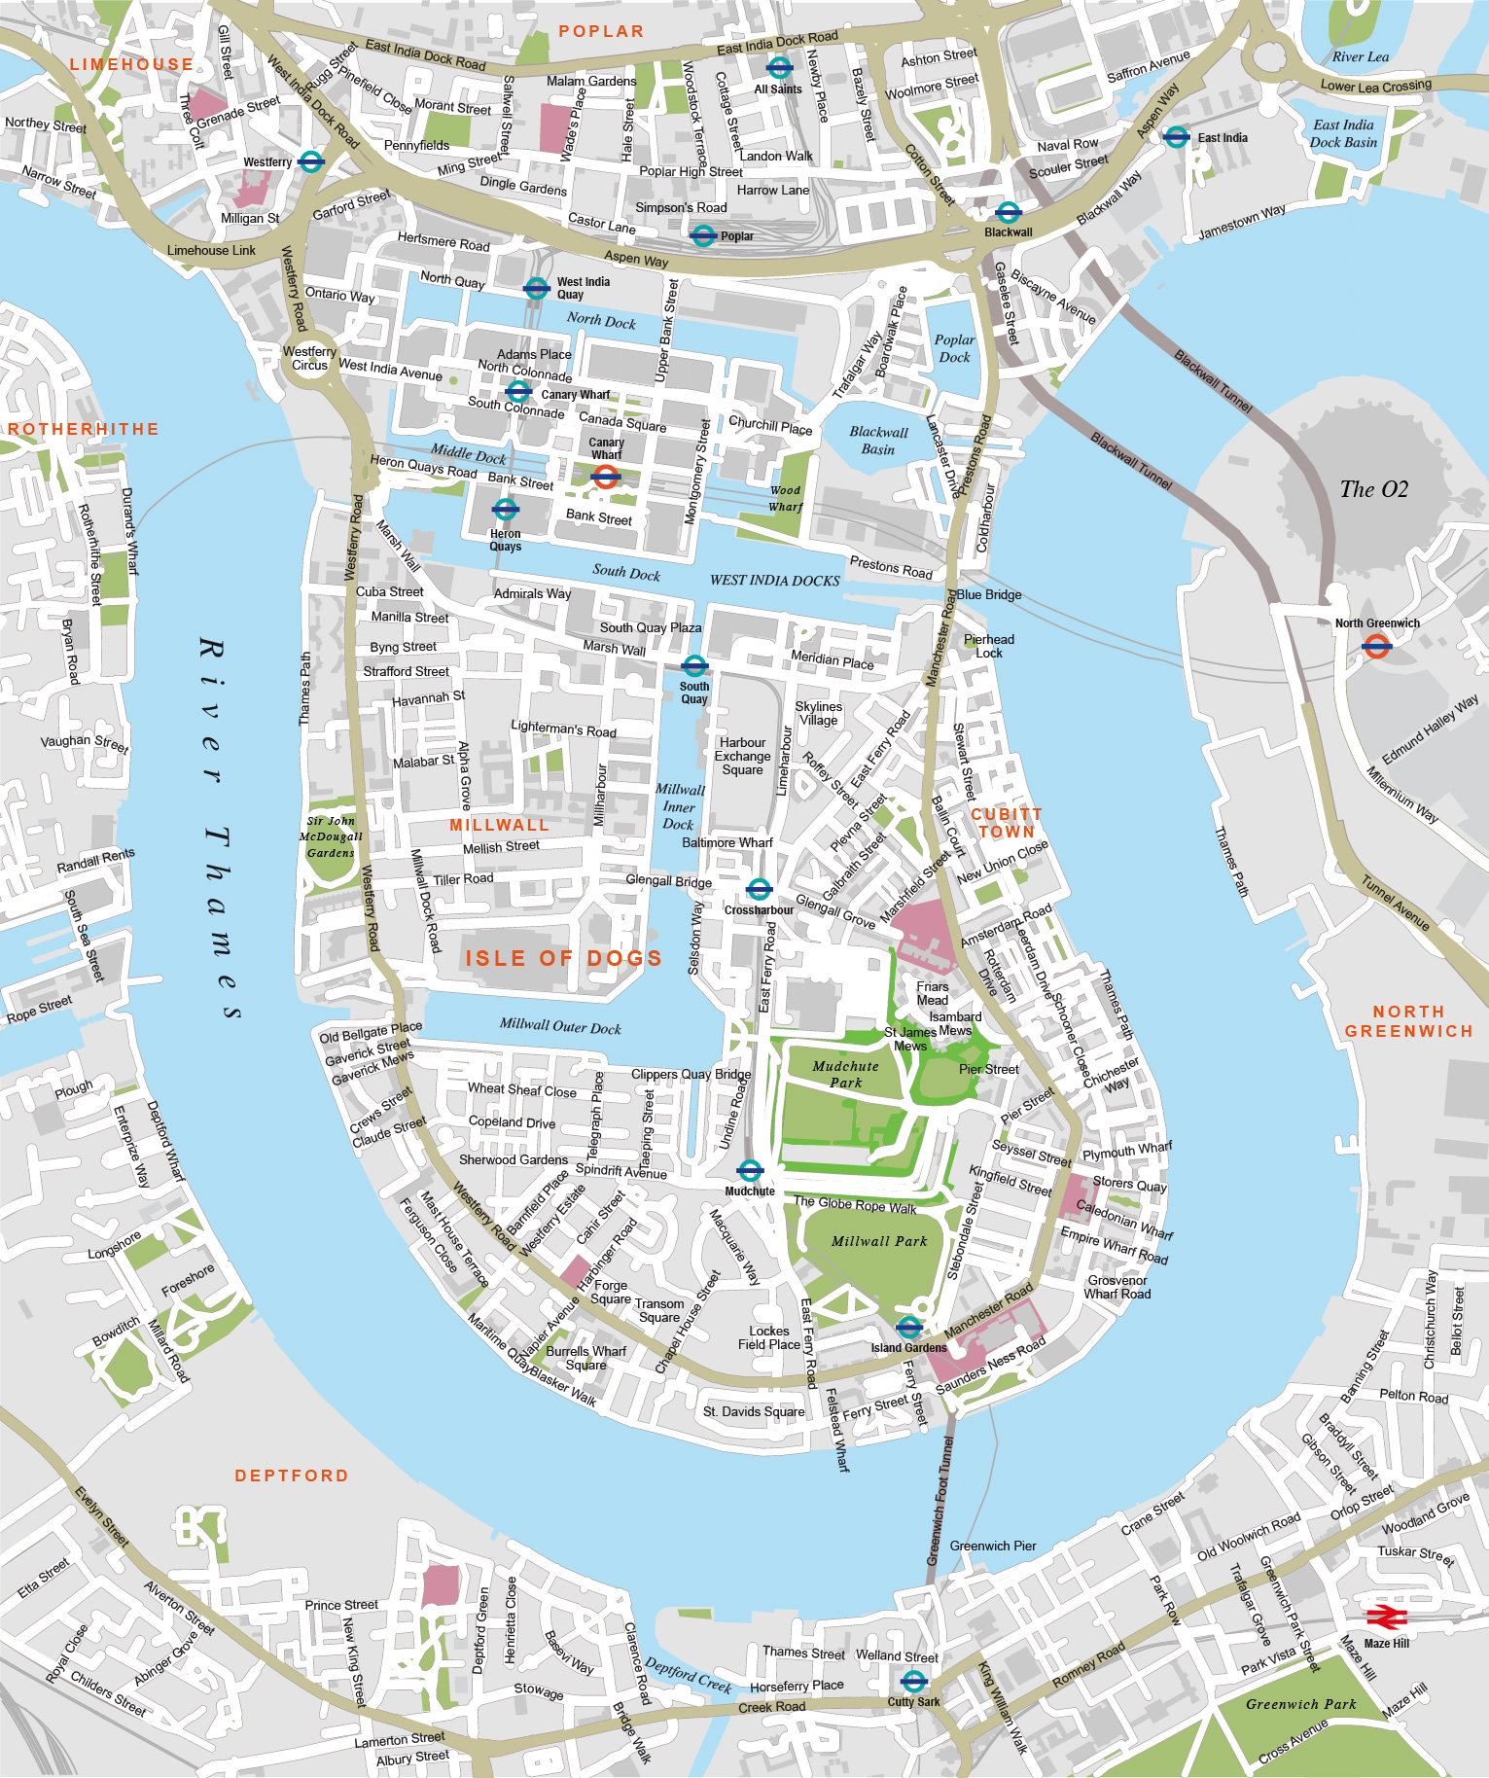

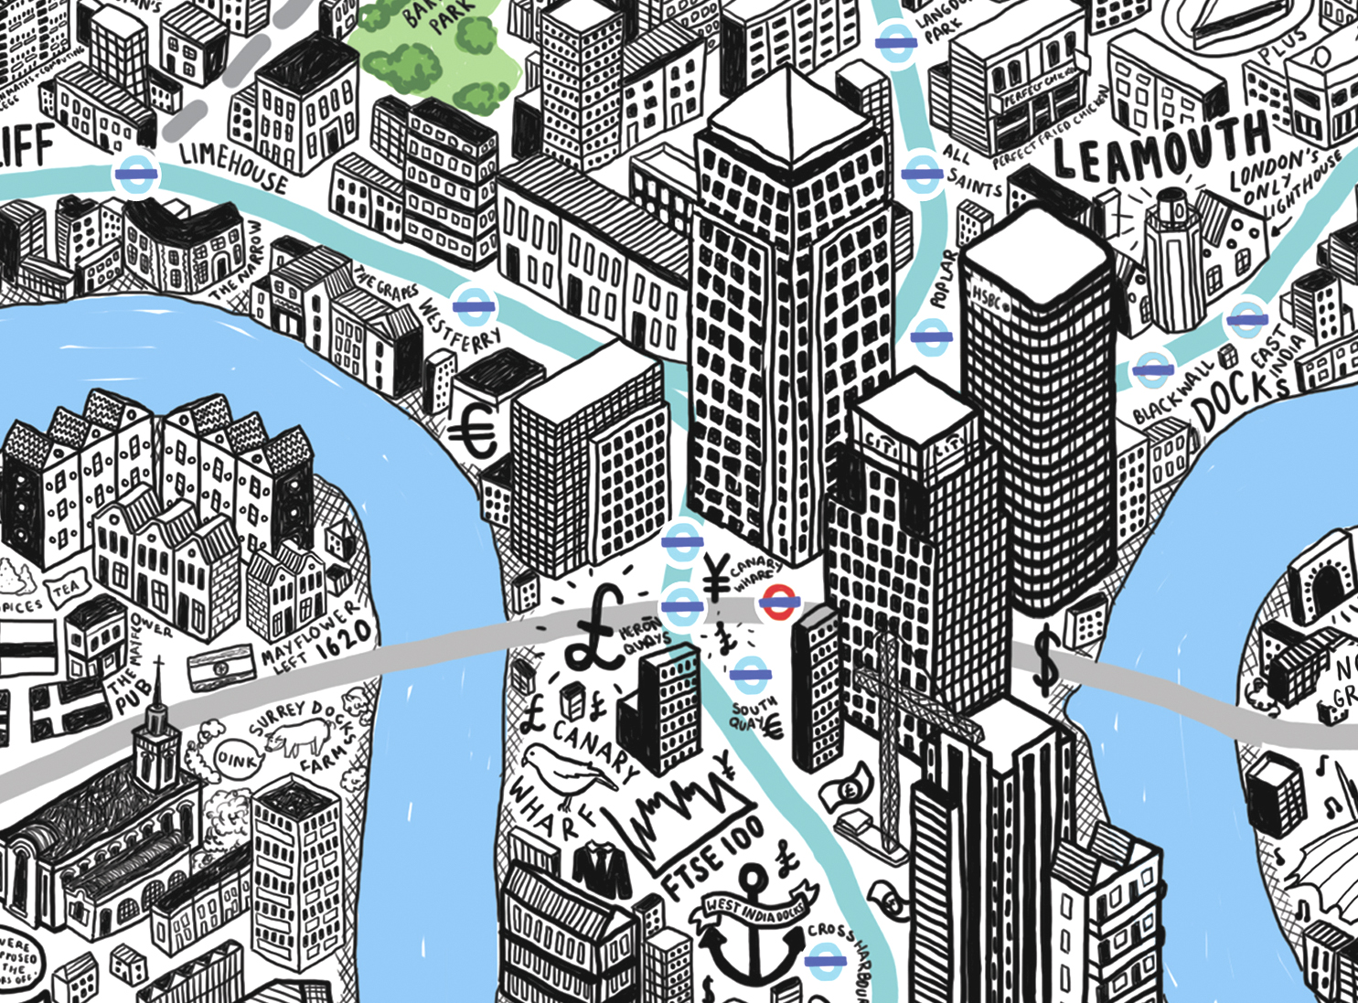

Section of Jenni Spark’s map of London, aimed to show the culture of each area.

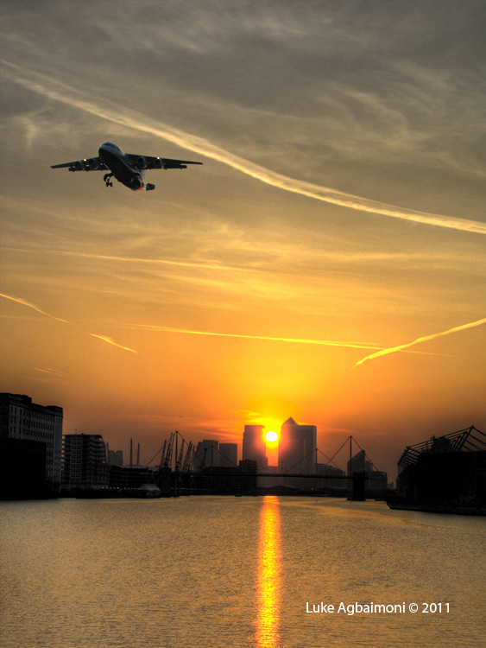
Photographs
Annotate these pictures to show how they differ in what they tell us about London Docklands.

‘I used to live near what was Surrey Docks, so I was always aware of the Docklands growing up. As I got more into photography it always amazed me how overlooked the Dockland areas were when it came to showing off London. The Docklands boast a great contrast of old and new, modern and historic, manmade and organic, so make a great subject for landscape images. [A favourite is] the bridge opposite the Excel Centre which has a fantastic cityscape view of Canary Wharf and the O2 centre. It’s best viewed at sunset.’

Luke Agbaimoni, Photographer

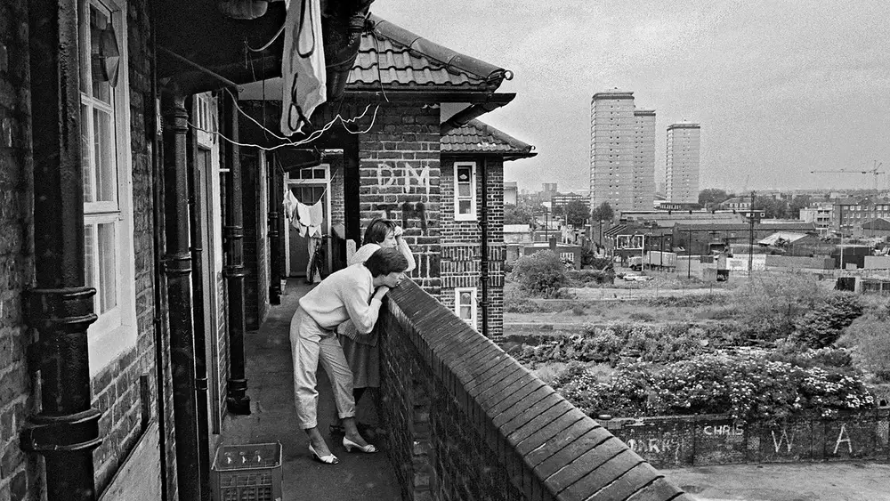
Photograph above from Mike Seaborne's book, The Isle of Dogs: Before the Big Money.
Also: look at London Docklands on instagram to get a broader understanding of different people’s attachment to the place.

Census data
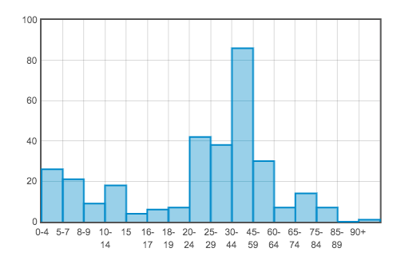
Annotate these maps and graphs to describe the demographics of the Isle of Dogs.
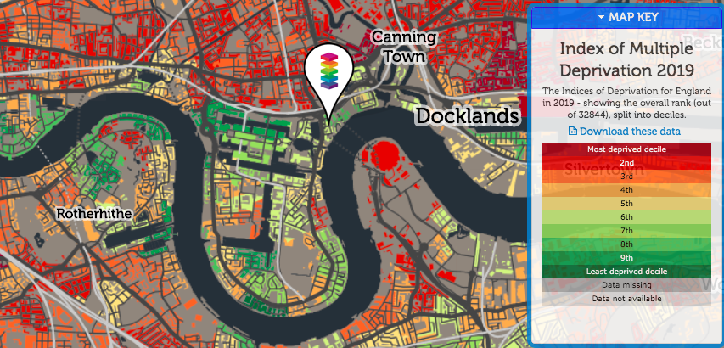

Age and social grade data for E14 9SJ, a road running through the centre of London Docklands.

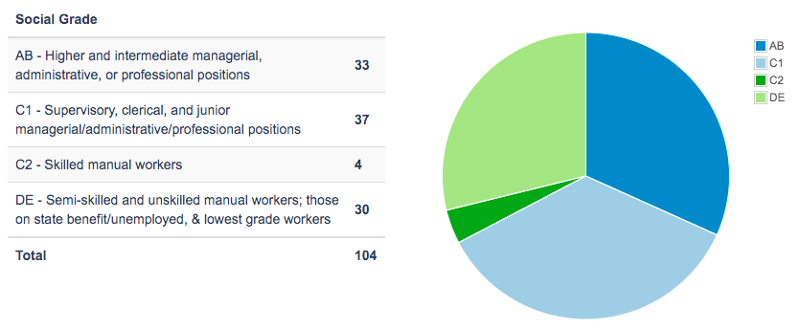

Poetry Annotate these poems to show how they differ in what they tell us about London Docklands.
- A Level student on field trip
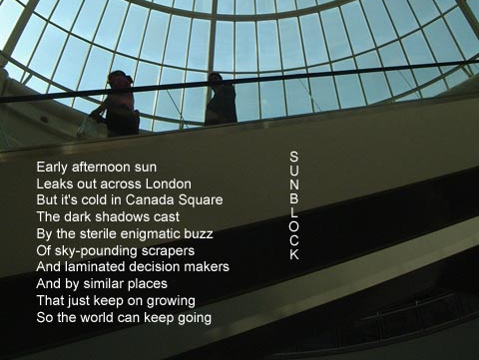

- By a diner visiting the Docklands

People think that London Docklands is an interesting area of the city,
An unusual mixture of urban regeneration and chic Victorian cityscape
And, as you know, the home of sickeningly rich, loft-living yuppies.

But, believe me, there is a very dark side to the area as well:
One evening not so long ago, I had just enjoyed a very tasty
Spaghetti alla vongole in a painfully trendy wine-bar cum bistro.

And what do you think happened? My brain blanches at the recollection
Of a group of champagne-swilling investment bankers in red braces
Emerging from an opium den, shouting horrid financial obscenities.

The filthy pigs started shouting and jeering and making fun of us
(n.b. my dining companion was a moustachioed dwarf lady)
And they thumped her brutal with their monogrammed baseball bats.

And to what end? Why, to relieve the tension of making thousands
Every goddam single day for doing virtually nothing, that's what!
Dear God, I shall try and avoid upmarket financial centres in the future.

Songs:

Annotate these songs to show how they differ in what they tell us about London Docklands.

‘Cardboard Box City’ by the Levellers

Have you seen them in every station
Begging in their separate ways
Some of them are no more than children
Some of them are runaways
I don't care for your opinion
I've seen you turn your face the other way
And you said son
What's your problem
Can't we talk about this over lunch some day

And I bet you've never
Been south of the river
Down the old Kent road or down
Southwark way
I bet you've never never seen them
Lying in the litter
In the cardboard boxes
Where you make them stay

In the docklands of East London
Where those great tall ships once sailed
Of a price of couple of hundred thousands
I have seen your condominiums for sale
In the north by the archway tavern
You can see them lying there every day
And they're drunk and they scream their minds to the heaven
Dear lord why did it have to be this way

And I bet you've never
Been south of the river
Down the old Kent road or down
Southwark way
I bet you've never never seen them
Lying in the litter
In the cardboard boxes
Where you make them stay

On the Waterfront- Cockney Rejects

Alright, i know it's sad soppy music
But i ain't taking the piss
Just wanna say the truth
Cos that's how this song is
Cos there's too many people
Thinking they're just like us
And if you wanna know the truth
They're full of puss
Hey little rich boy what do you wanna do
Wanna be a rebel in your
New bondage suit
Got a license to scream anarchy
It's all over now
Your daddy he could buy you
Anything you want
But the fact that matters most
Is that he can't
He can't buy our way of living
It's all over now
Now i know what you wanna be
You're crying inside to be some one like me
The truth hurts more than anything
That is why those words that you sing
Now i'm standing on the water front
I wanna know who's the biggest c*nt
Cos on the waterfronts where
You wanna be
It's all over now
You wanna plat at being rebels
But you know you ain't on that level
And if you could change for just a day
You wouldn't wanna stay that way
You wouldn't want to stay that way
You'd soon run back to what you was
And that can only be because
A little public school boy sing

About the waterfront
You don't know what it means
You poor misguided c*nt
But it ain't really the place to go
Listen to the ones
The ones who really know
Yeah i mean the dockers sons
The forgotten ones you know
I know that you wanna be like me
You hate being in your middle class tree
Cos on the waterfronts where
You want to be
Where you wanna be

Contrasting Place Research task

Now that you have considered how different pieces of information help to convey both descriptive representations of place and people’s sense of place, you are going to carry out your own research.

Collect and analyse (comparing to London Docklands) the following for Brighton:

Maps (use google maps to help)
Census Data
Photographs
Social Media
Poetry
Songs

You may also want to consider how Covid-19 will impact people’s sense of place in each location.

Further reading:

If you are interested in reading more about place here are some good reads. Search them on Google Scholar and many have free links. I have attached Place and Placelessness as a starting point.

Anderson, J., 2015. Understanding cultural geography: Places and traces. Routledge.

Cresswell, T., 2014. Place: an introduction. John Wiley & Sons.

Massey, D., 2013. Space, place and gender. John Wiley & Sons.

Seamon, D. and Sowers, J., 2008. Place and placelessness (1976): Edward Relph. Key texts in human geography, pp.43-52.

https://www.geography.org.uk/Changing-place-changing-places--

A Level Physical Geography Pre-work:
Water and Carbon Cycle

Initial focus:

To consider how we can answer the question: "Which is preferable, economic development or the preservation of natural habitats and traditional cultures?"

How will we do this?

We will look at a number of case studies from across the world, along with some of the associated geographical concepts and processes that underpin them.

We will use a variety of resources: magazine and news articles, video clips and your own research.

This is unchartered territory in many respects, but also gives us an excellent opportunity to develop skills and explore ideas that we would not have time to do so ordinarily.

So, to the investigation itself:
"Which is preferable; economic development or the preservation of natural habitats and traditional populations?"

For each article you read:

State the facts.

Analyse them:
- Why might they be significant?
- What impacts may there be?
- For whom and for how long?

Evaluate them:
- How important are they?
- For whom and for how long?
- Do they really matter?
An example is below:

Facts:
The Vuntut Gwitchin are an indigenous group of people living in northern Canada. Their traditional way of life relies on hunting caribou that migrate through the area on their way to and from their calving grounds in the 1002 lands in Alaska.
Caribou numbers are declining, perhaps as a result of climate change which have led to quotas being imposed on the VG when hunting.
The US are considering drilling for oil in the 1002 lands.
The VG have limited other sources of income. In the settlement of Old Crow, that can only be accessed by air or boat and where there is a population of 245, there are some jobs (12) available in the local quarry and others work in the school and local government offices.

Analysis:
Drilling in the 1002 lands would disrupt the caribou and lead to lower numbers which would put increased pressure/further quotas on the VG. Without the meat from the caribou, their way of life will not survive as the cost of importing food is so high. This would mean that younger members of the tribe are likely to move away from the area, to towns and cities for work. This would mean that the traditional way of life would come to an end as skills and knowledge would not be passed on.
Oil from the 1002 lands will increase energy security for the US, help make US “great again” (Trump), provide jobs and oil .

Evaluation: Your opinion as to what you think is the best option:

On the one hand, currently a glut of oil, oil prices are low so not economically worth drilling. This could change in time.
Old Crow - only 245 people - is it that big an impact? How much does it matter about traditions?
Environmental impact on 1002 lands - highly environmentally sensitive area?
You need to make this decision and justify it!

Resources
Water and Carbon Cycles

Shades of green: how Guyana is balancing ecotourism with oil production https://geographical.co.uk/people/development/item/3565-spotlight-guyana

Essential oil?
https://geographical.co.uk/places/forests/item/2820-essential-oil

Palm oil linked to stream damage
https://geographical.co.uk/places/wetlands/item/562-palm-oil-linked-to-stream-damage

Keeping it local – indigenous conservation
https://geographical.co.uk/places/forests/item/2450-keeping-it-local

REDD+ or dead?
https://geographical.co.uk/places/forests/item/2173-archive-redd-or-dead

Logged off: can deforestation be controlled?
https://geographical.co.uk/places/forests/item/2123-logged-off-can-deforestation-be-controlled

Protecting the corridor
https://geographical.co.uk/places/forests/item/1456-protecting-the-corridor

A billion for Brazil
https://geographical.co.uk/places/forests/item/1334-a-billion-for-brazil

Stop cattle laundering, save the Amazon
https://geographical.co.uk/places/forests/item/1030-stop-cattle-laundering-save-the-amazon

Looking differently
https://geographical.co.uk/places/forests/item/432-looking-differently

Climate change and coral reefs
https://repository.si.edu/bitstream/handle/10088/2199/Hugues_et_al.pdf

These pictures reveal the dramatic difference in soil erosion along country borders https://geographical.co.uk/people/development/item/3595-soil-erosion-differs-dramatically-along-country-borders-suggesting-individual-governments-can-make-a-difference

Requirements to start course:

Print the human section of the booklet and annotate the figures. Bring this and your own research on Brighton to the first lesson of the year.

Complete a summary for each of the articles you read, minimum of 2 and bring this to your first lesson of the year. Use the example as a guide to how much you need to write.

