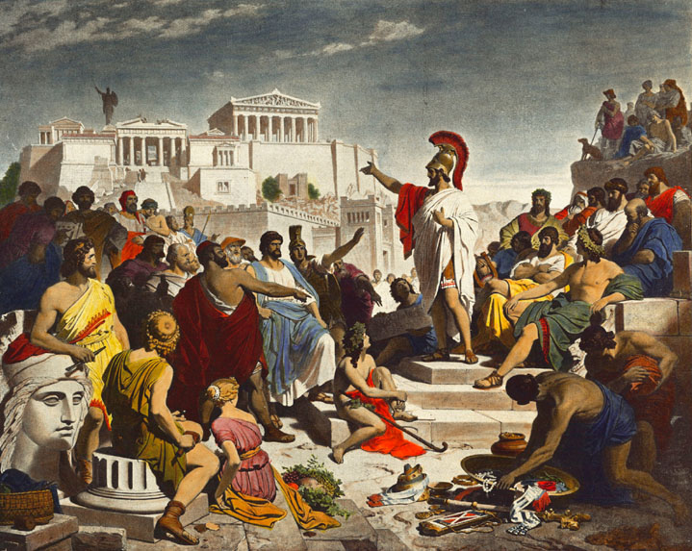
CLASSICAL CIVILISATION
Introduction booklet

Name:
________________________________________________________

________________________________________________________

Contents

Specification overview…………………………………………………………………………………………………Page 3

Assessment overview……………………………………………………………………………………...…………..Page 5

Expectations and lesson requirements…………………………………………………………………………Page 8

Introductory tasks………………………………………………………………………………………………………..Page 9

Further reading……………………………………………………………………………………………………….…Page 21

Specification overview
You will study three components, in this order:
- Homer’s Odyssey (‘World of the Hero’ compulsory component)
- Greek Theatre (‘Culture and the Arts’ component group)
- Democracy and the Athenians (‘Beliefs and Ideas’ component group)
Required books
As a large part of this course involves reading material from the classical world, you will need to get these books in order to be ready to study these components:
- Homer, ‘Odyssey’ translated by E. V. Rieu, revised translation by D. C. H. Rieu (Penguin) (ISBN 9780140449112) [World of the Hero component]
- Virgil, ‘Aeneid’ translated by D. West (Penguin) (ISBN 9780140449327) [World of the Hero component]
- for Oedipus the King, translation by Fagles, in The Three Theban Plays (Penguin) (ISBN 9780140444254) [Culture and the Arts component]
- for Bacchae and Frogs, the appropriate volume of Cambridge Translations from Greek Drama:
  - Bacchae: ISBN 9780521653725 [Culture and the Arts component]
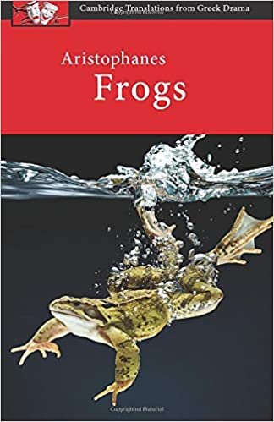
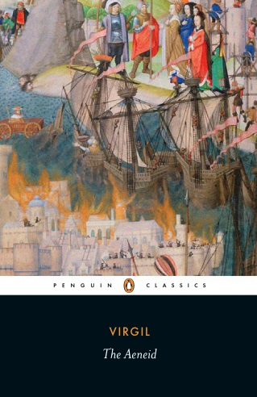
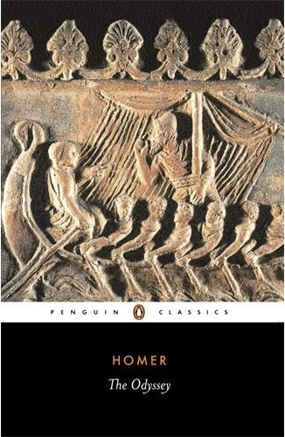
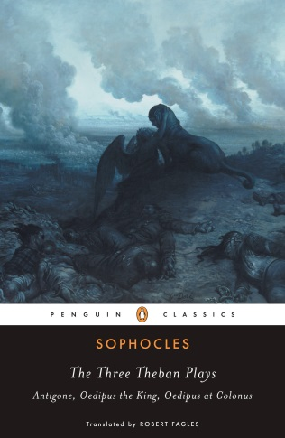
  - Frogs: 9780521172578 [Culture and the Arts component]
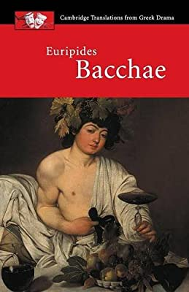

World of the Hero (compulsory component)
In this compulsory component you will study one of Homer’s Odyssey, as well as Virgil’s Aeneid. You will develop an increasingly sophisticated level of knowledge and understanding of the epics themselves, the way in which they were composed, and the religious, cultural and social values and beliefs of its society. Both texts should be studied in equal levels of depth and will be given an equal amount of teaching time.
The poems of Homer were considered by the Greeks themselves to be a foundation of Greek culture, standing as they do at the beginning of the Western literary canon. This component provides you with the opportunity to appreciate the lasting legacy of the Homeric world and to explore its attitudes and values. The epics of Homer, with their heroes, gods and exciting narratives, have been in continuous study since their conception, and remain popular with you and teachers today.
This component also provides you with the opportunity to appreciate Virgil’s Aeneid, a cornerstone and landmark in Western literature. Drawing inspiration from Homer, as well as from his own cultural and political context, Virgil explored what it was to be a hero in the Roman world and created a work which has proven enduringly popular.
Greek Theatre (‘Culture and the Arts’ component group)
You will study the drama produced in the ancient Greek theatre, which forms some of the most powerful literature of the ancient world, and has had a profound and wide-reaching influence on modern culture. To fully understand this cultural phenomenon, you will study not only the plays but the context in which their form and production developed. To develop this understanding this component involves the study of the physical theatre space used by the Greeks to stage their dramas, and also depictions of this staging in the visual/material record. This study of the production of Greek drama is coupled with an in–depth study of three plays (Oedipus Rex, Bacchae, Frogs), all of which have proven to be enduring favourites. The themes and concepts explored by these plays are of significant relevance and interest as much to the modern audience as they were to that of the original performance. The plays and material culture included in the specification provide you with a range of interesting sources which will allow you to explore, evaluate and understand this aspect of ancient culture and its relevance to us in the modern world.
Democracy and the Athenians (‘Beliefs and Ideas’ component group)
The aim of this component is to examine the concept of Democracy; what this meant to the Athenians, and its positive and negative aspects. You will have the opportunity to study the reforms of two key thinkers in depth, Solon and Cleisthenes, and assess the extent to which they laid the foundations for the democracy of the 5th century BC. You will look at how democracy permeated Athenian identity, how it was celebrated and idealised, but also how it was criticised. The concepts of ‘popular’ leaders who mislead the people, or give them what they want rather than what they need, and a voting public who may not be fully informed on the issues, may resonate with the modern world and make this study of one of the West’s foundational political ideas engaging and relevant. Finally, you will study extracts from the comedies of Aristophanes, whose biting wit and political satire can still capture a modern audience as well as it did an ancient one.
Assessment overview

World of the Hero (compulsory component)

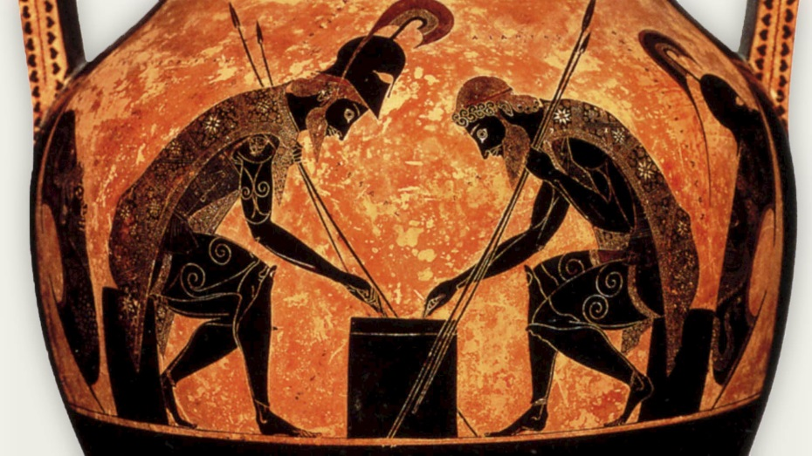
This compulsory component will be testing AO1 (knowledge & understanding) and AO2 (analysis and critical thinking).
The examination is worth 100 marks and lasts 2 hours and 20 minutes. This represents 40% of the total marks for the A Level.
The exam will consist of three sections:
- Section A focuses solely on Homer and will contain two sets of questions; one on the Iliad and one on the Odyssey. You should answer the questions on the text you have studied.
- Section B contains questions focusing solely on Virgil’s Aeneid, and all questions in this section are compulsory.
- Section C contains a stimulus question in which students draw on both a passage from Homer (either the Odyssey or the Iliad) and one from Virgil; and a choice of essays.

In these essays you will be expected to make use of secondary sources and academic views to support your argument.
There are three question types in this exam, they are:
- 10 mark stimulus question (where you read a passage from the text and analyse it)
- 20 mark essay
- 30 mark essay

Greek Theatre (‘Culture and the Arts’ component group)
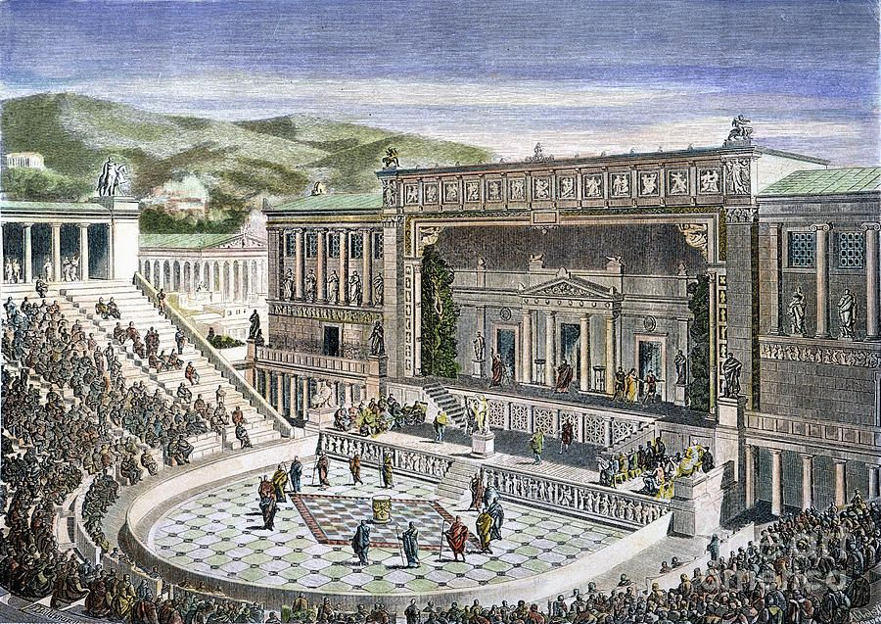
This will be testing AO1 and AO2.
The examination is worth 75 marks and lasts 1 hours and 45 minutes. This represents 30% of the total marks for the A Level.

The examination will consist of two sections:
- All questions in Section A are compulsory. These will involve short answer questions and commentary questions which respond to two stimuli from the prescribed sources list of differing types, and a shorter essay question which takes one or both sources as its starting point.
- Section B contains a choice of one from two essays.

In these essays you will be expected to make use of secondary sources and academic views to support your argument.
There are four question types in this exam, they are:
- Short answer question
- 10 mark stimulus question
- 20 mark essay
- 30 mark essay

Democracy and the Athenians (‘Beliefs and Ideas’ component group)
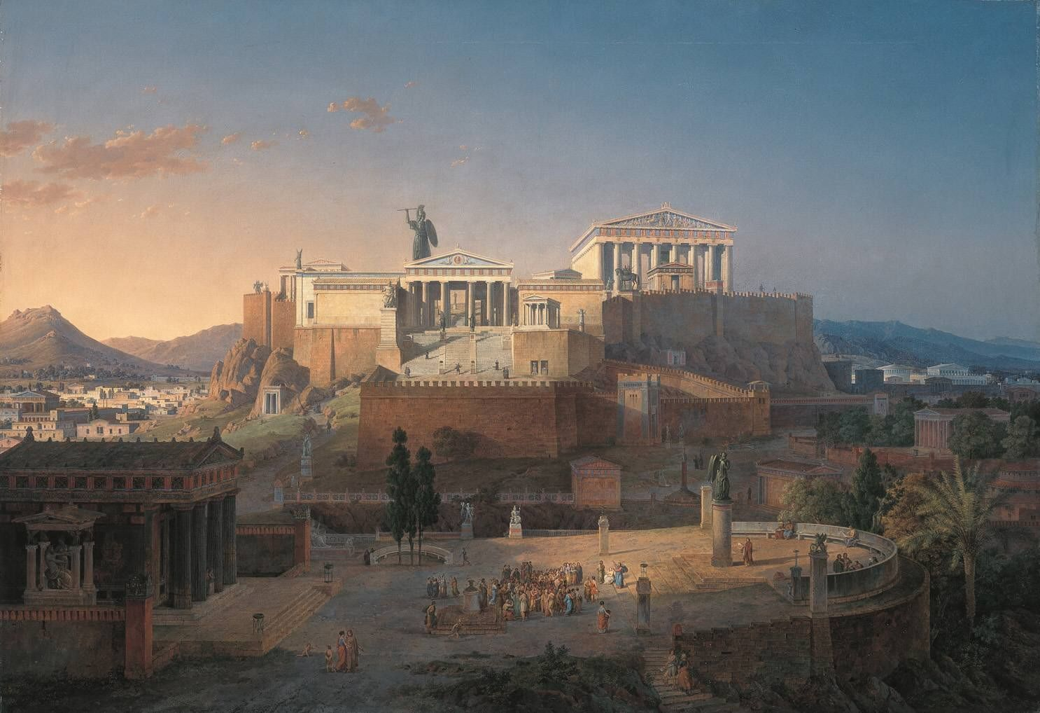
This component will be testing AO1 and AO2.
The examination is worth 75 marks and lasts 1 hours and 45 minutes. This represents 30% of the total marks for the A Level.

The examination will consist of two sections:
- All questions in Section A are compulsory. These will involve short answer and a commentary question responding to one stimulus from the prescribed sources list, and the same style of questions discussing an idea from one of the key thinkers, and a shorter essay question which takes the source, idea or both as a starting point.
- Section B contains a choice of one from two essays. In these essays you will be expected to make use of secondary sources and academic views to support your argument.

There are five question types in this exam, they are:
- short answer question
- 10 mark stimulus question
- 10 mark idea question
- 20 mark essay
- 30 mark essay

Expectations and lesson requirements
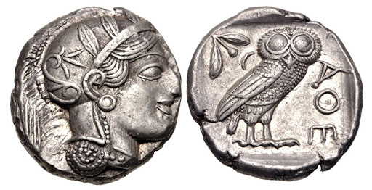
Material requirements:
- Pen
- Pencil, rubber
- Ruler
- Lined paper
- A folder

As with any other A-Level, you will need to be well-organised and have a folder for the different components that we will do. You will need to keep your work neatly and safely stored, so that you can make use of it in the future when you go over your past work.

When we are going through the first two components (World of the Hero, Greek Theatre) you will need to bring with you to every lesson the text that we are studying.
You will also need to bring the textbook (the school will provide you with one) to most lessons, and I will indicate when.
Homework will be given every week so that you either consolidate what we have done or prepare for what we are about to do; this will be on Show My Homework and you will be told about this in class as well. It is important that you keep on top of your work (both classwork and homework) so that you don’t fall behind.
You will need to be on time every lesson and ready to begin promptly, with all your equipment and books out.

Tasks

Task 1: The Trojan War fact-file
The Trojan War is one of the most famous myths in the world, and is a lynchpin in the formation of ancient Greek myths. What was it and what was its significance? How likely is it that it really happened?
These are some of the questions I you should consider when creating this fact-file.
Organise it around these key themes and figures:
- Mycenae (home of Agamemnon, the Greek war-master of the expedition)
- Troy
- Causes, events, and outcome
- Agamemnon, Achilles, Nestor, Odysseus
- Paris/Alexandros, Hector, Priam, Hellen
Starting places:
https://en.wikipedia.org/wiki/Trojan_War
https://www.ancient.eu/Trojan_War/
https://www.britannica.com/event/Trojan-War
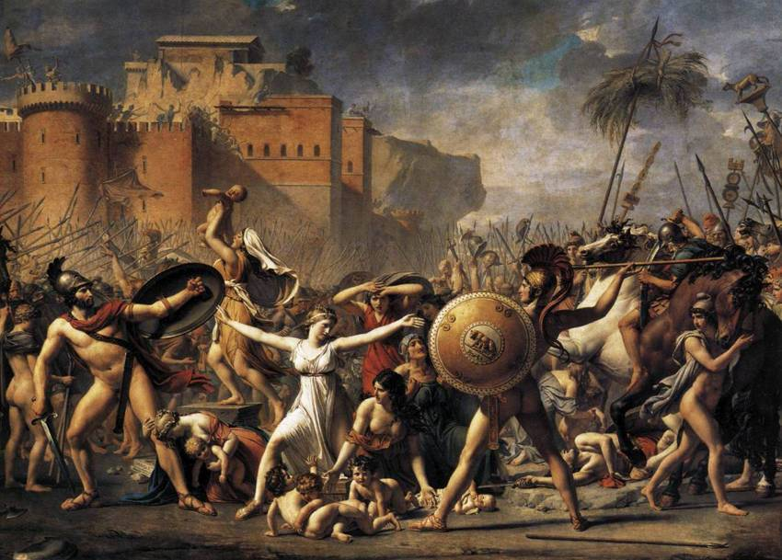

Task 2: The Mediterranean
What is the Mediterranean? This sea was the home to all the great sea-faring civilisations of the ancient world, and you need to be very familiar with it. Study maps of the ancient Mediterranean and locate these regions and settlements, then tick them off. Here are a few maps that you can start with:
Mycenae (city) | Troy (city) | Rome (city)
Syracuse (city) | Carthage (city) | Latium (region)
Ithaca (island) | Hellespontus (region) | Alexandria (city)
Sicily (island) | Crete (island) | Cyprus (island)
Lydia (region) | Phrygia (region) | Etruria (region)
Achaea (region) | Corinth (city) | Attica (region)
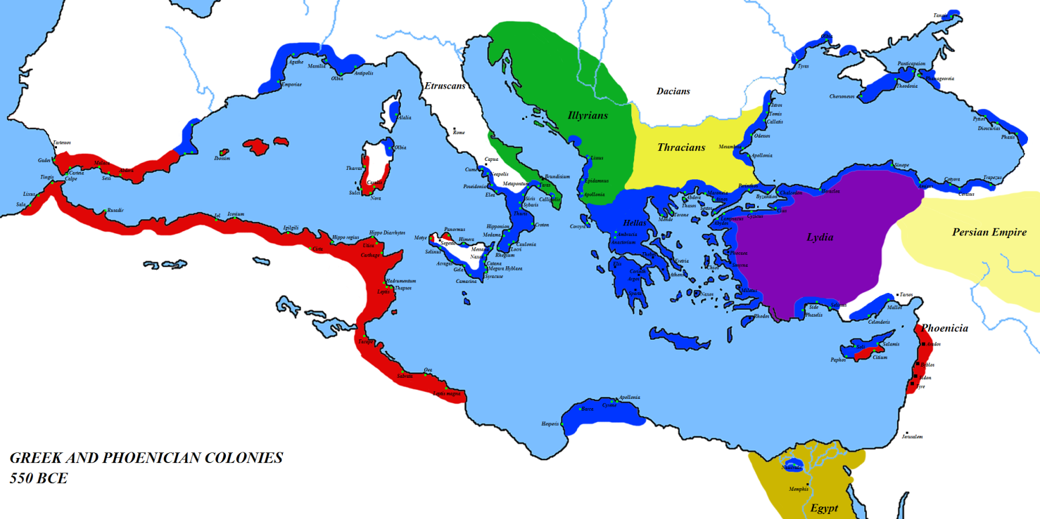
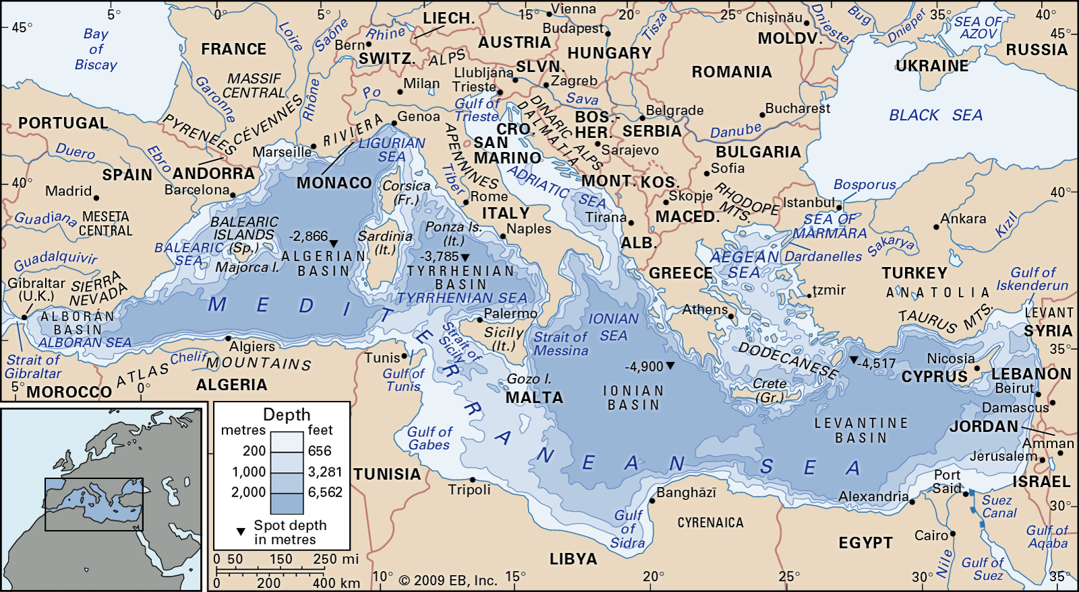
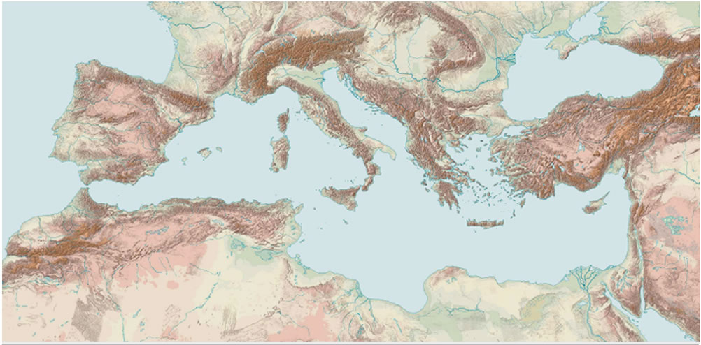
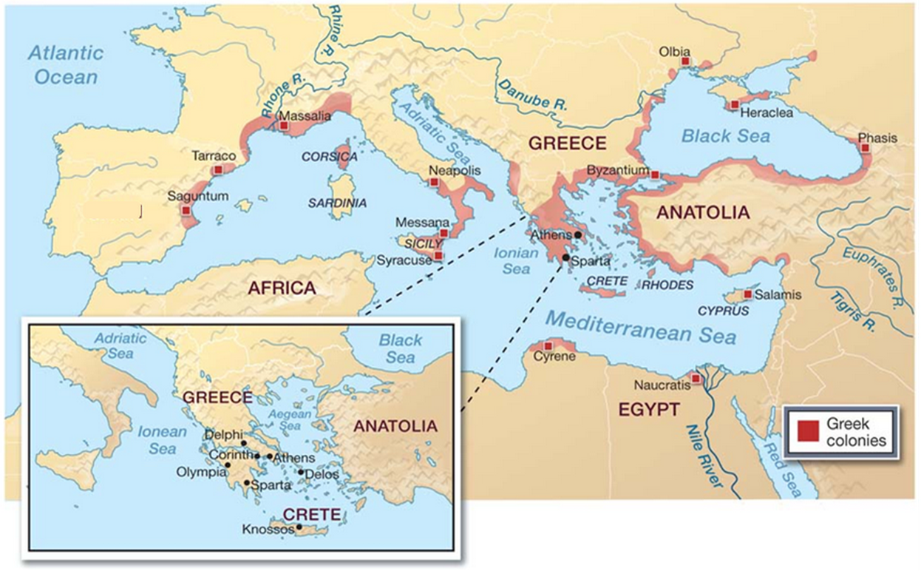

Task 3: timeline on ancient Greece
Create a timeline on ancient Greece, from the Early Bronze Age (c. 3000 BC) to the Roman conquest of Greece (146 BC). On it, plot:
- What state dominated Greece
- Key technological, political, and philosophical developments
- Key figures (e.g. Alexander the Great, Pericles, Socrates)

Again, Wikipedia is a good starting place, but do not rely on it completely. Here are some other places to look at:
https://www.bbc.co.uk/bitesize/topics/z87tn39/articles/zxytpv4
http://www.ancientgreece.co.uk/
https://www.britannica.com/place/ancient-Greece

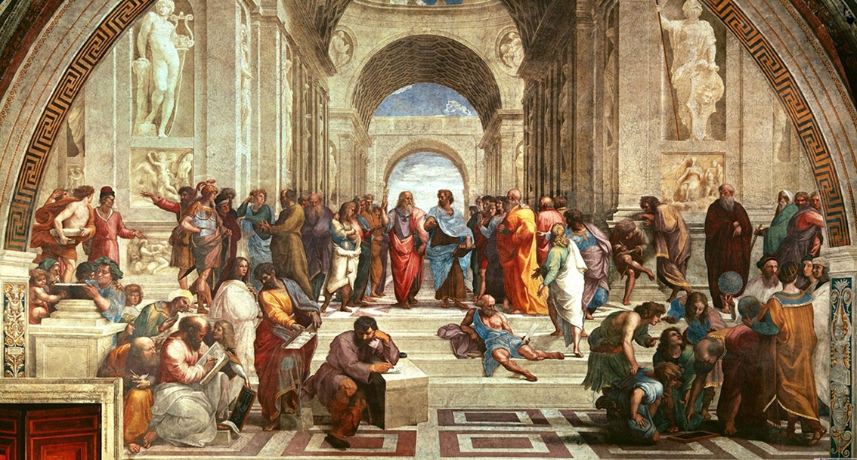

Task 4: the collapse of Mycenae and the coming of the ‘Sea People’
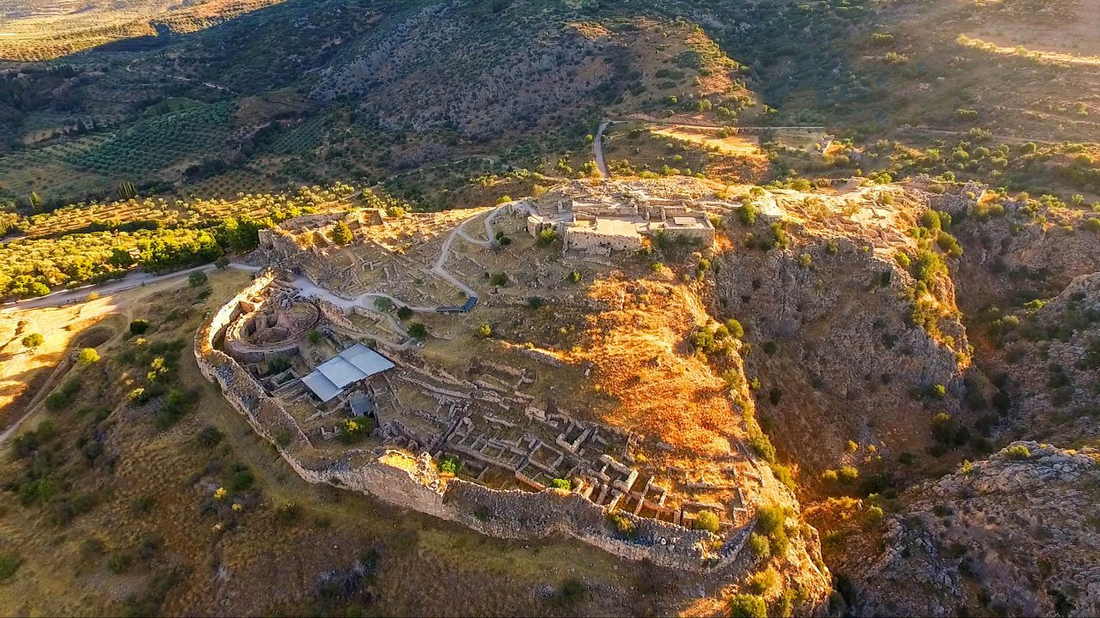
The collapse of the Mycenaean civilisation of Greece is the background from which we will start the course, so it would benefit you to learn about this development.
Create a fact-file on the collapse of the Mycenaean Greece (Late Bronze Age) and include the causes and consequences of this.
Starting sources:
https://www.historywiz.com/mycenaeanfall.htm
https://en.wikipedia.org/wiki/Mycenaean_Greece
https://www.ancient.eu/Mycenaean_Civilization/
https://www.greece-is.com/news/mycenaean-civilization-collapsed-peloponnese/
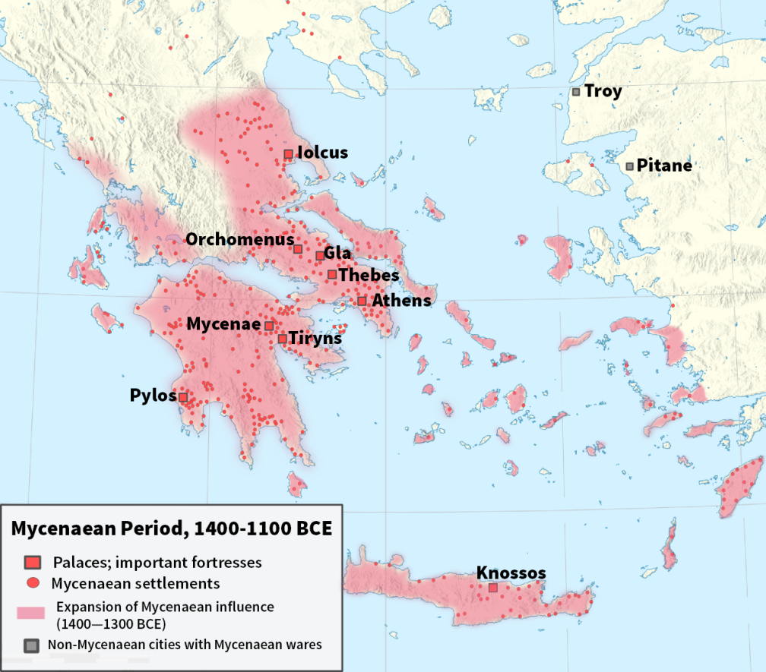

Task 5: key terms
Research the meaning of these key terms:
Time | Epithet | Simile | Xenia
Kleos | Furor | Pietas | Proem
Fate | Pathos | Dramatic Irony | Flashback
Patronymic | Nostos | Motif | Ekphrasis
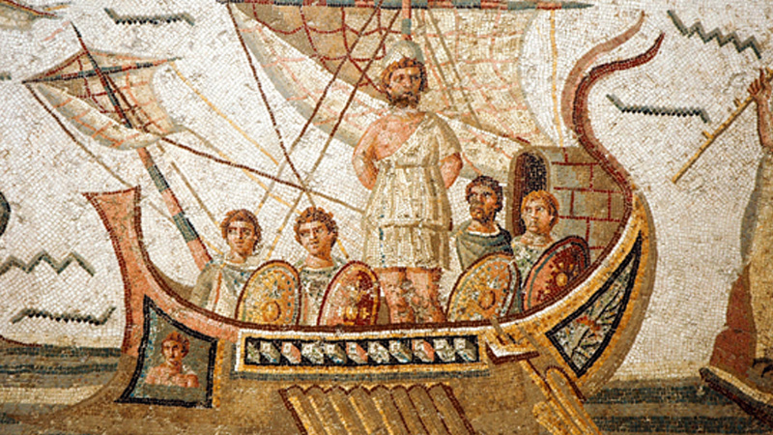

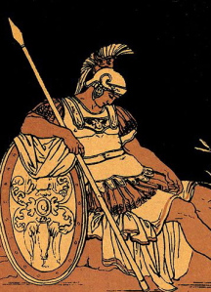

Task 6: timeline of Greek Theatre
Create a timeline on playwrights and the plays they wrote in ancient Greece. You will focus mostly on the 5th Century BC, and in particular plot on it the works of these playwrights:
- Sophocles
- Aristophanes
- Aeschylus
- Euripides
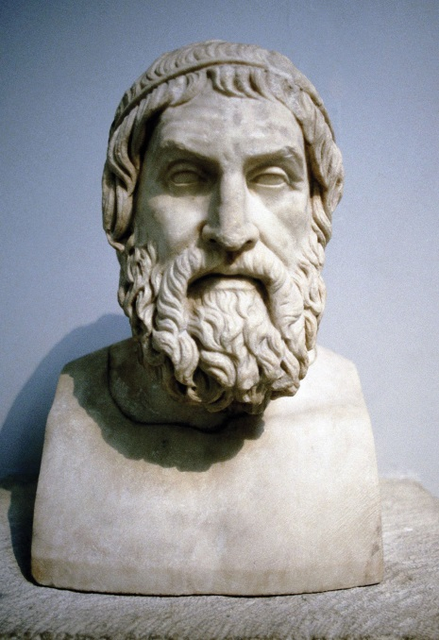
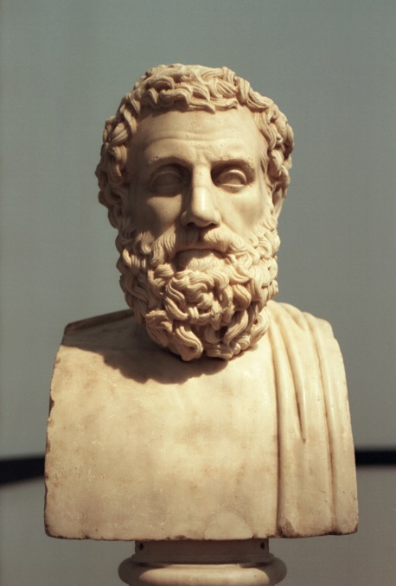

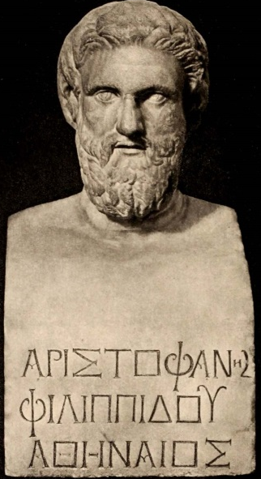
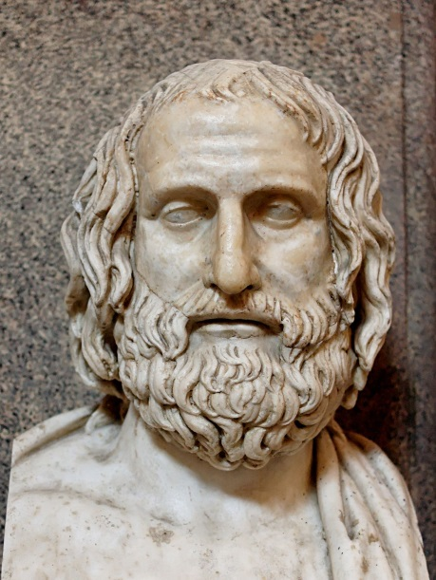

Task 7: the characteristics of theatre
We have the benefit of living in a world where there are plenty of plays, musicals, and operas that take place – all of which try to emulate that ancient Greek theatre in one way or another. As we will be studying ancient Greek theatre, it would be best for you to look at modern theatre and see its characteristics, as well as some recreations of ancient theatre. What are its key features and how does it display them live to an audience?
Watch these clips and write down your thoughts on:
- The use of props (what kind of props and physical items are used)
- Costumes (how they are employed)
- Settings (how filmmakers and playwrights make use of the physical environment around the actors)
- The use of music to create atmosphere and tone
- Singing and talking (how actors project their voice and how they convey dialogue and meaning to the audience)
- Actors’ body language and physical acting
Les Miserables (2012) – ‘Look down’: https://www.youtube.com/watch?v=cyqURSNx-KY
Monty Python and the Holy Grail – ‘She’s a witch!’: https://www.youtube.com/watch?v=zrzMhU_4m-g
Book of Mormon – ‘Hello’: https://www.youtube.com/watch?v=OKkLV1zE8M0
School of Rock – montage: https://www.youtube.com/watch?v=FTxqH0tukqQ
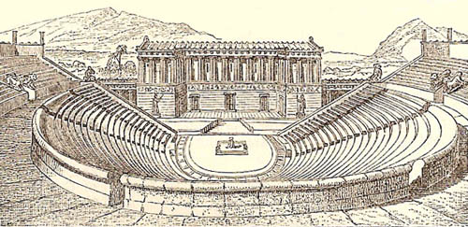
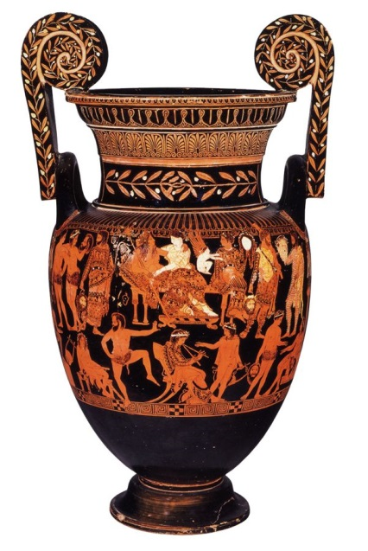

Task 8: Oedipus Rex
This is the first of the three plays that we will study, and this video is a nice introduction to get you thinking about the key themes presented in it.
Write down notes around these questions:
- What key themes are presented in the play?
- What is the overall plot of the play?
- Why do these themes resonate with audiences today?

Crash Course literature – Oedipus Rex: https://www.youtube.com/watch?v=Cj7R36s4dbM
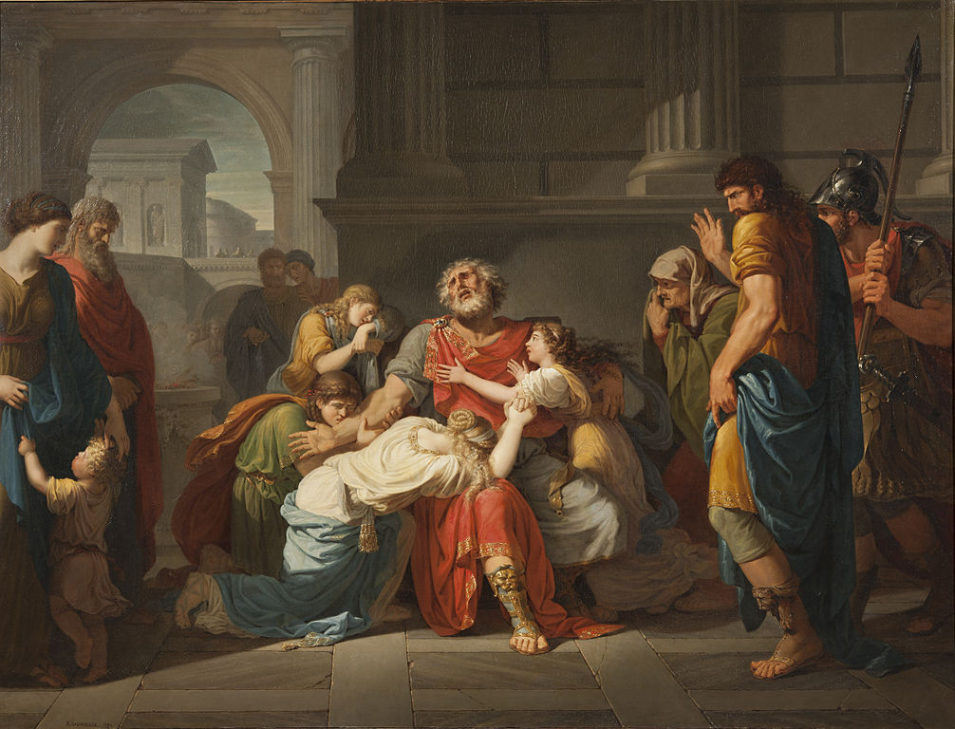

Task 9: key terms
Find out the meaning of these key terms that are related to ancient Greek theatre:
Lenaea | Dionysus | Rural Dionysia | Choregos
Proagon | Pompe | Dithyramb | Komos
Theoric Fund | Prohedria | Theatron | Skene
Orchestra | Eisodos/parodos | Scholion | mechane

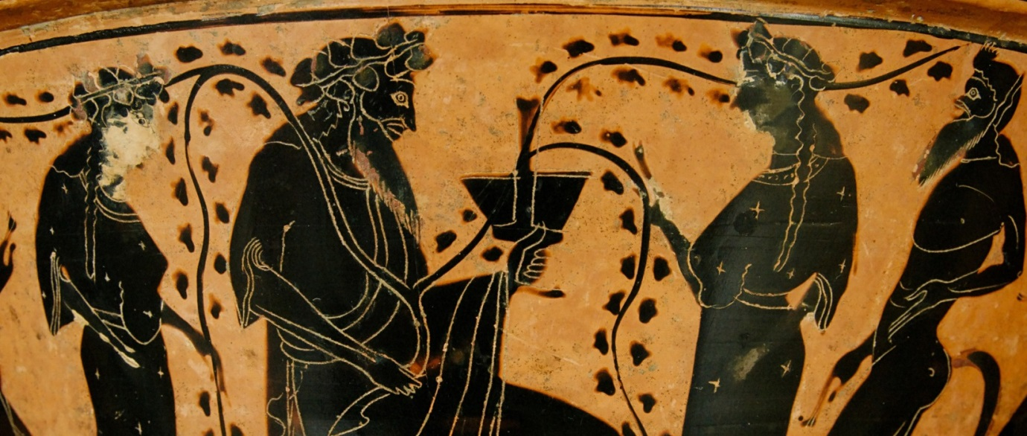
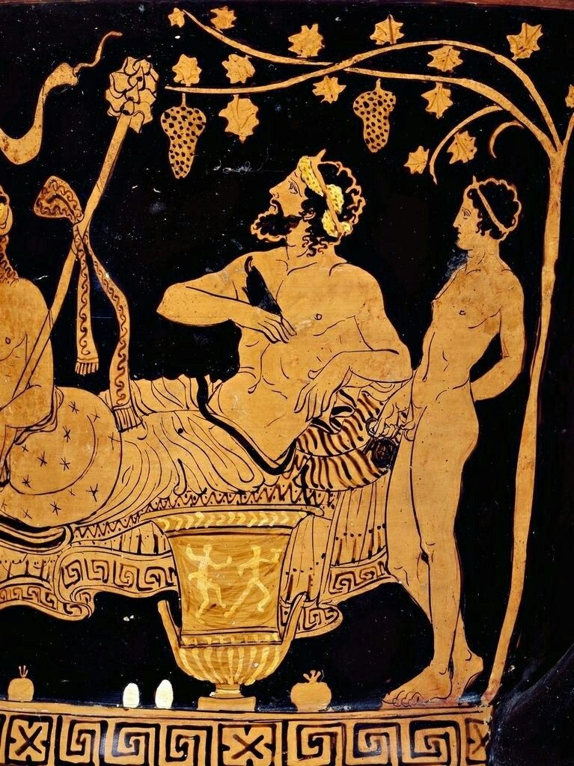

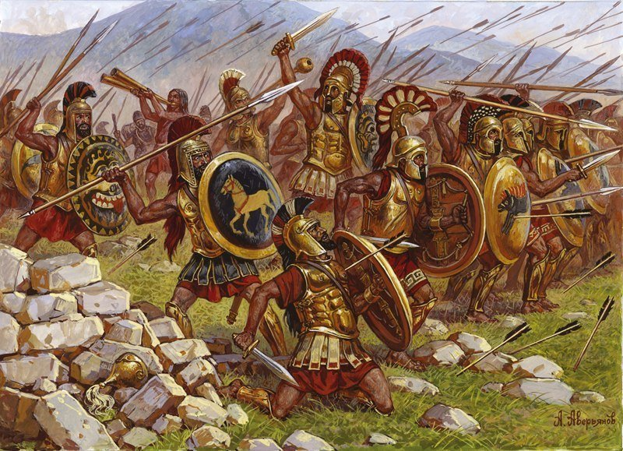
Task 10: Peloponnesian War (431 – 404 BC)
Research the wars between Athens and her allies versus Sparta and her allies in the 5th Century BC. Produce a fact-file on them, including:
- Causes
- Events
- Consequences
- Key battles
- Leaders
- Theatres of warfare: land and sea
https://www.britannica.com/event/Peloponnesian-War
https://www.history.com/topics/ancient-history/peloponnesian-war
https://www.ancient.eu/Peloponnesian_War/
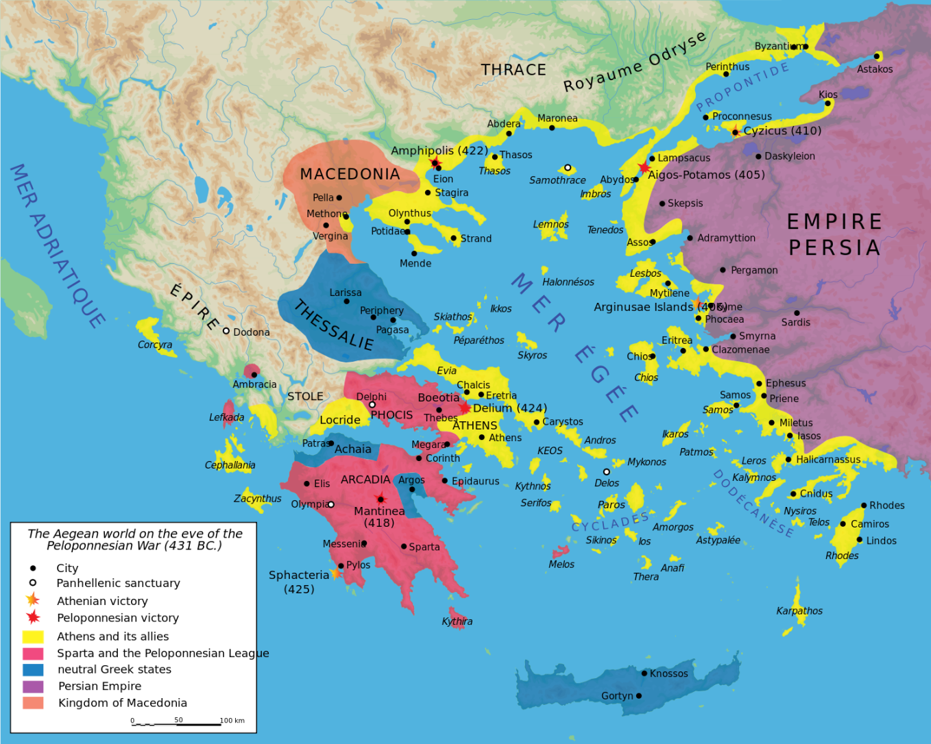

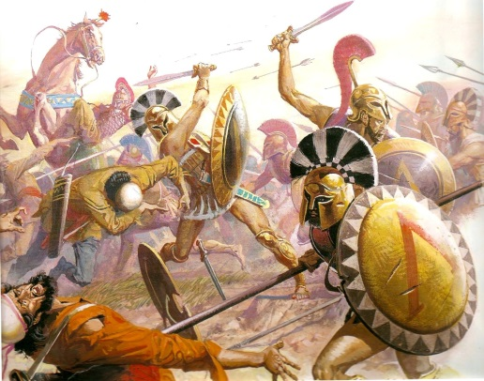
Task 11: Greco-Persian Wars (547 – 449 BC)
Research the wars between the Persian Empire and the Greek city-states of the classical period and produce a fact-file on them, including:
- Causes
- Events
- Consequences
- Key battles
- Leaders
- Theatres of warfare: land and sea
In particular, with regards to the consequences, pay close attention to the rise of the Delian League and the rise of the Athenian Empire.
https://www.britannica.com/event/Greco-Persian-Wars
https://www.ancient.eu/Persian_Wars/
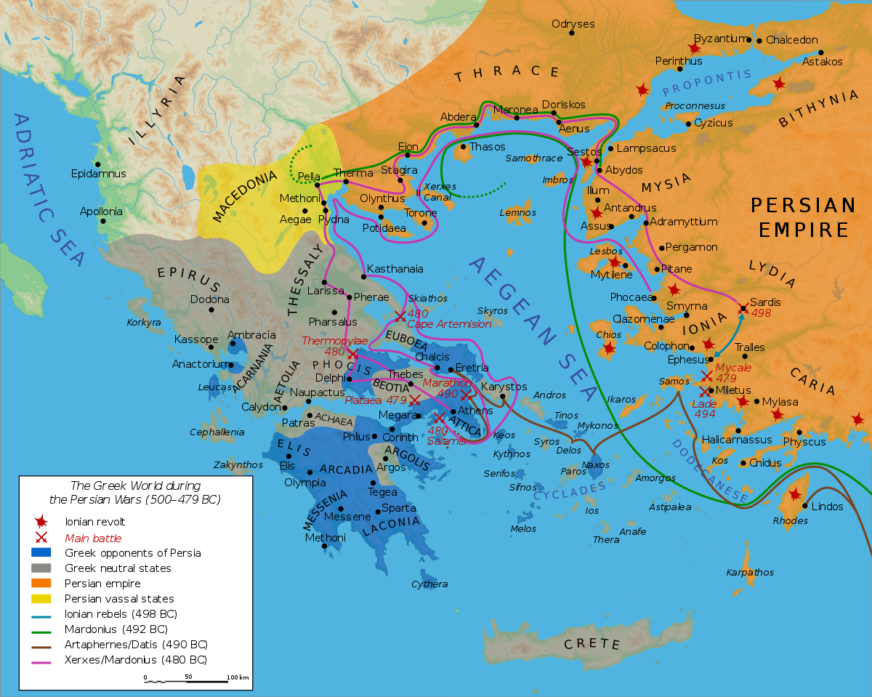
https://www.newworldencyclopedia.org/entry/Greco-Persian_Wars

Further reading

Books by Stephen Fry – ‘Mythos’ (ISBN 978-1405934138) and ‘Heroes’ (ISBN 978-1405940368)

BBC Ancient Greece – ‘The Greatest Show on Earth’ (documentary series)
- Part 1: https://www.youtube.com/watch?v=FAkLTWQUbG8
- Part 2: https://www.youtube.com/watch?v=EaRIZIPAL6M
- Part 3: https://www.youtube.com/watch?v=tnqz1zxGDTA

Thomas R. Martin – ‘Ancient Greece: from prehistoric to Hellenistic times’ (ISBN 9780300160055)

James Renshaw – ‘In search of the Greeks’ (ISBN 9781472530264)

James Renshaw – ‘In search of the Romans’ (ISBN 9781853997488)

Ian C. Storey and Arlene Allan – ‘A Guide to Ancient Greek Drama’ (ISBN 9781405102155)

A. H. M. Jones – ‘Athenian Democracy’ (ISBN 9781376328547)

