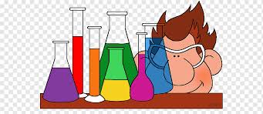

The Transition from GCSE to A-Level
By: Dr. M. Salem

CHEMISTRY AT BETHS GRAMMAR SCHOOL
A few words from the Head of Chemistry
In Chemistry one might think some topics are repeated from GCSE to even degree level, however every time a topic is discussed, we delve into it a bit deeper.
At GCSE you might be asked, which element is more reactive, Na or K? and you may correctly answer, K. But at AS level you will learn why? And the more you learn about the whys and the hows, the more enjoyable the subject becomes. I promise!
I would also like to add that, if chemistry is taught the right way and learnt the right way, it will not be as challenging as most fear. I always say to my students, you learn Chemistry through rationalisation and not memorising.
Your foundation needs to be sound to prepare you for the next jump. I have prepared some areas in bullet points for you to go over again and then some questions, which if you learn to do, then your transition to studying A-level chemistry would be a smoother one. But even if you cannot, don’t worry, you will learn them in the lessons.
I have prepared a brief list of areas related to chemistry, that I give to any year 11 students intending to do A-level chemistry but need to know more about the place and relevance of the subject.
Have a read.

Why Chemistry?
Let us see which fields and industries are related to Chemistry. A few are:
- Energy and Fuels
- Air conditioning and Refrigeration
- Coal related chemicals
- Industrial gases
- Industrial Carbon
- Ceramic Industry
- Portland Cement
- Glass Industry
- Metallic salts
- Chlor-Alkali Industries
- Electrolytic Industries
- Electrothermal Industries
- Elemental industries, e.g. Phosphorous, Potassium, etc.
- Nitrogen Industries, Including Chemical Fertilisers
- Sulphur and Sulphuric Acid
- Acids and Alkalis
- Nuclear Industry
- Explosive Industry
- Photographic Industry
- The Steel Industry
- Surface Coating
- Food and food by-products
- Agrichemical industries
- Fragrances, Flavours and Food Additives
- Oil, Fats, Waxes
- Soap and Detergents
- Sugar and Starch Industry
- Wood-derived industries
- Pulp and Paper industry
- Plastics, the Polymer industry
- Man-made fibre and film industry
- Rubber industry
- Petroleum Processing
- Petrochemicals
- Dyes
- Pharmaceutical Industries
- All Medicinal fields
- All that happens in our body are series of ‘Chemical Reactions’, e.g. respiration, digestion, etc.
- All that takes place in plants, e.g ‘photosynthesis’.
- Etc.
So, the question should be, what isn’t Chemistry?!!

Areas to go over again
Please remember, you are not expected to know the content of A-level chemistry before you start the course. Much of what would be beneficial for you to do is a clearer understanding of the areas and topics you have already studied at GCSE. Reviewing some of these areas are highly advisable. These include:
- The idea of the atom and how it came to be considered as nucleus in the middle and with electrons orbiting round it.
- Bonding, whether ionic, covalent, or metallic
- Formula of compounds – but you will learn this in 10 minutes!
- Balancing equations
- Preparation of salts
- Acids and alkalis
- The trend of reactivity in the Periodic Table. Let me explain this:
Put two fingers in the middle of a periodic table. As you drag your right finger to the right, they become more non-metallic, and as you go up, they become more reactive as non-metals. Now, if you drag the other finger to the left, they become more metallic, and as you go down, they become, more reactive as metals. Now you have just learnt the order of reactivity of (almost) all the elements in the periodic table!
- The idea of mole.
- The idea of concentration.
- Calculating the concentration of an unknown alkali, using an acid of known concentration. So many come to A-level classes, who haven’t understood this part well. So, have a go again.
- Basic Organic chemistry, the chemistry of compounds in which Carbon is present. You may ask why is this important? Well, every molecule in your body, is carbon based. Sugar, proteins, enzymes, hormones…
- Alkanes and Alkenes.
- Polymers
- Knowing about functional groups. The part of the organic compound, that gives it a particular property.
- Carboxylic acids
- Alcohols
- Esters
- At AS level you will come across, Aldehydes and Ketones
- At AS level you will learn about Isomerism
- At AS level you will learn about Shapes of compounds
The more you learn, the more questions you can answer, and therefore the more enjoyable the subject becomes. It is a challenging but a rewarding subject. But you must be prepared to work hard, persevere and remain resolute and steadfast. Let me ask you a seemingly simple question.
Why does (table) salt dissolve?
If you can answer (without help), you probably are already an A* student. I must warn, the answer isn’t simple. So that’s your first search for an answer. Have a go!
Now a few Questions
- What is the mass of 0.02 moles of Na2SO4 (sodium sulphate)?
- How would make 200 ml of 0.2M solution of NaCl?
- Show how Propene polymerises.
- Why is HCl more acidic than Ethanoic acid?
- Write a balance equation for the complete combustion of heptane.
- How would we make ethyl ethanoate?
- Why is Chlorine more reactive than Iodine?
- Why is K more reactive than Na?
- Advantages and disadvantages of flame test?
- In the Chemistry laboratory, what might be the wrong things to do?

Hopefully when I see you in my class, I will go through the answers with you.
Dr. M. Salem
The Periodic table
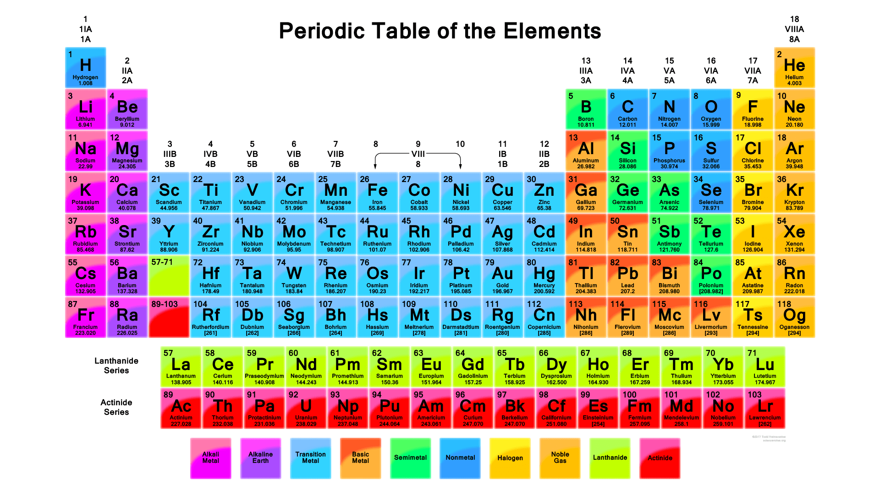

The Glassware we use
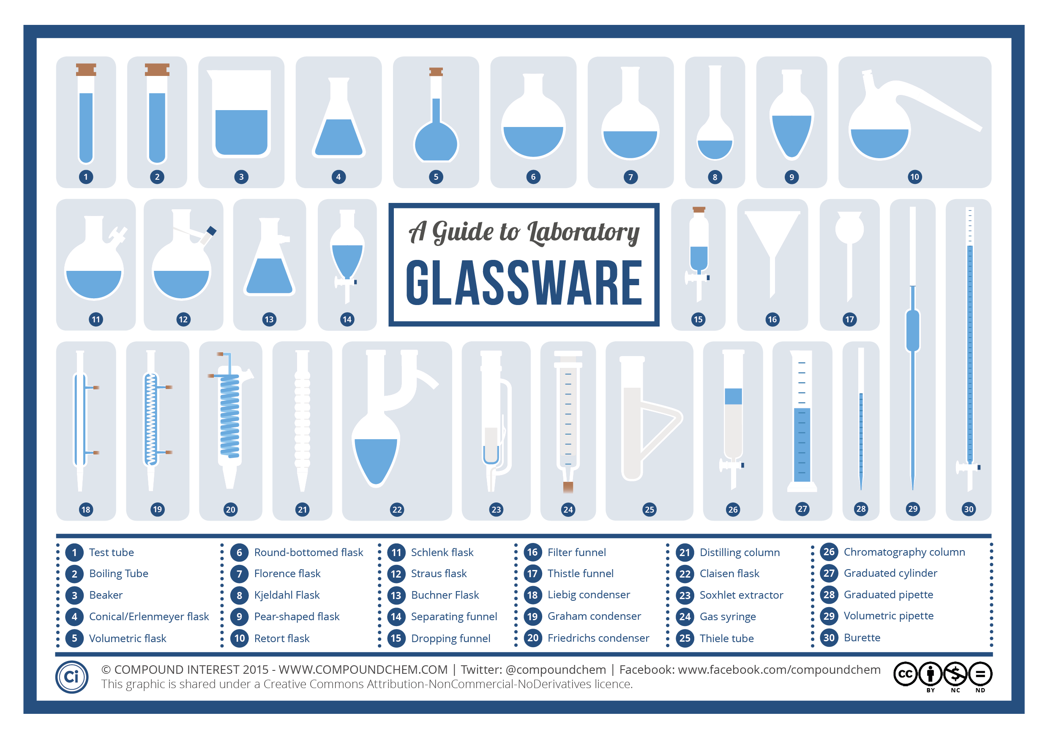
The Hazard Signs
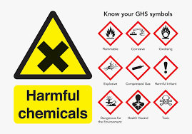
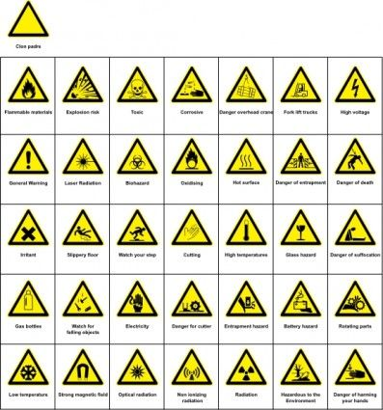

Chemical equations
Take a look at this free website.
http://www.ncert.nic.in/ncerts/l/jesc101.pdf

The Units in Chemistry and sciences
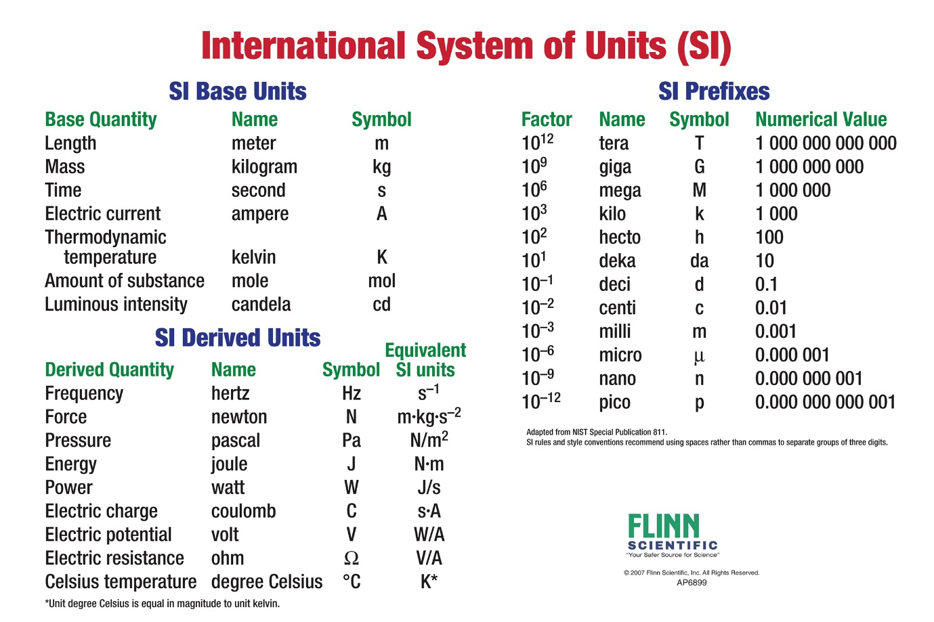

Books, Journals and Websites
There are an enormous array of Books, Journals and websites that would be enormously useful to broaden your knowledge of chemistry. It is enormously important for you to engage in a broader reading and research in chemistry as it will provide you with the relevance and importance of chemistry in literally most fields of research and development in any Chemical, Pharmaceutical and Medicinal laboratories and industries.

BOOKS
All the ones below are FREE to download.
https://chemistry.com.pk/free-download-chemistry-books/
https://bookboon.com/en/chemistry-ebooks
http://elibrary.bsu.az/books_400/N_184.pdf
http://nongnu.askapache.com/fhsst/Chemistry_Grade_10-12.pdf
https://openedgroup.org/books/Chemistry.pdf
https://www.hemethigh.com/apps/pages/index.jsp?uREC_ID=290557&type=u&pREC_ID=936194
http://www.openculture.com/free_textbooks
https://openstax.org/details/books/chemistry-2e

Journals
The one below gives you access to countless free website for free downloads.
http://abc-chemistry.org/
Websites
chemistry-past-papershttp://www.fastpastpapers.com/page828.html
https://revisionscience.com/gcse-revision/chemistry/chemistry-gcse-past-papers/ocr-gateway-gcse-chemistry-past-papers
https://mathsmadeeasy.co.uk/gcse-chemistry-revision/
https://www.amazon.co.uk/New-Grade-9-1-GCSE-Chemistry/dp/1782945164 (you have to pay for this one)
https://www.myrevision.online/ (this is useful for other sciences as well as Maths)
http://www.knockhardy.org.uk/index.htm (very comprehensive)
There are countless more, do a bit of further searching yourself, but I am sure there is enough, above to keep you busy.

